ANNEXURE-10
Mandatory Disclosures

1. Name of the Institution:
Bharati Vidyapeeth’s Institute of Management Studies & Research,
Sector No. 8, C.B.D., Belapur, Navi Mumbai – 400614, Maharashtra, India.
Telephone No.: 022-27572433 / 27562582, Fax No.: 022-27571183
Email ID: director@bvimsr.org,
director.imsr@bharatividyapeeth.edu
Website: www.bvimsr.org
AICTE Permanent ID: 1-9397684
DTE Code: MB3101
University of Mumbai Code: 18

2. Name and Address of the Trust and the Trustee:
Bharati Vidyapeeth
Bharati Vidyapeeth Bhavan,
13, L.B.S. Marg, SadashivPeth,Pune-411030
Telephone No.: 020-24407100, Fax No.: 020-24339121
Email ID: kadamvishwajeet@gmail.com
Website: www.bvuniversity.edu.in
Sl.No | First Name | Academic Qualification | Land Phone Number | Address Line 1
1. | Dr.Vishwajit Patangaro Kadam | B.E. (Computers) M.B.A., Ph.D. | 020-25655188 | 1, Opp. B.M.C.College, Sinhgad, Pune
2. | Shri Anandrao Bahirji Patil | B.A.,B.T. | 020-25386302 | E-101, Woodland Apartment, Near Gandhi Bhavan, Pune
3. | Dr. Shivajirao Shripatrao Kadam | M.Sc., Ph.D. | 020-25448676 | "Ashirwad", 15, Mayur Colony, Pune
4. | Dr. Shakarrao Ramchandra Suryawanshi | M.A., Ph.D. | 02162-250412 | 'Janai', Plot No. 25, Yashwant Housing Society Genda Mal, Satara
5. | Shri Shankarrao Maruti Dingane | M.A.,M.Ed. | 020-26877952 | 'Shashank ',Sadhana Sahakari Gruhrachana Societ, Near Akashwani, Pune
6. | Shri. Vasantrao Bhagwat Mhetre | B.Sc., B.Ed. | 020-25283074 | 'Prayag ', Bharatinagar, Paud Road, Pune
7. | Dr. Mahadev Shivling Sagare | M.Sc., Ph.D., DSC. | 020-25282119 | 17,Origin, Bharati Nagar Part 2, Paud Road, Pune
Trustee Details:

3. Name and Address of the Director:
Dr. Anjali Avinash Kalse
D-102, Omshiv Darshan CHS, Sec-15, CBD, Belapur,
Navi Mumbai-400 614
Mobile No.: +91 9869613429
Email ID: dranjalikalse@yahoo.com

4. Name of the affiliating University: University of Mumbai

5. Governance:

- Members of Governing Body
Sr.No. | Name of the Member | Designation
1. | Dr. Vishwajeet Patangrao Kadam, Secretary, Bharati Vidyapeeth Pune | Chairman
2. | Dr. K.D. Jadhav, Joint Secretary, Bharati Vidyapeeth Pune | Member
3. | Dr. Vilasrao J. Kadam, Regional Director, Bharati Vidyapeeth Educational Complex, Navi Mumbai | Member
4. | Shri. P.N. Tondan, Principal, BharatiVidyapeeth Technology, Navi Mumbai | Member
5. | Mr. Wilson Lukaso, Principal, BharatiVidyapeeth Hotel & Tourism Management Studies, Navi Mumbai | Member
6. | Director, AICTE Western Region, Mumbai | Member
7. | Director, Technical Education Maharashtra | Member
8. | Dr. Anjali Avinash Kalse, Director, Bharati Vidyapeeth’s Institute of Management Studies & Research, Navi Mumbai | Member-Secretary

- Establishment of Grievance Redressal Committee for Faculty, Staff and Students:

Designation | Name of Committee Member | Profession | Associated with | Mobile No. & Email ID
Chairman | Dr. Anjali Kalse | Director | BVIMSR | +91 9869613429  director.imsr@bharatividyapeeth.edu
Representative from Civil and Police Administration | Dr. Sanjay Sinha | Academician | BVIMSR | +91 9819217565  sanjaysinha@bvimsr.com
Local Media | Prof. Priyeta Priyadarshani | Academician | BVIMSR | +91 8454843474  priyeta.priyadarshini@bvimsr.com
Faculty Member | Dr. Rajani Mathur | Academician | BVIMSR | +91 9322677316  rajni.mathur@bvimsr.com
Practicing Physician | Mr. Mankar | Physician | BVDCH | +91 9869137381
Non Teaching Staff Member | Mr.Balasaheb Mandake | Clerk | BVIMSR | +91 9869341867  mandakebd@gmail.com
Non Teaching Staff Member | Mrs. Varsha Gawali | Clerk | BVIMSR | +91 8108411426  varsha@bvimsr.com
Faculty Member | Dr.Vijay V Bidnur | Academician | BVIMSR | 9921070209  vijay.bidnur@bvimsr.com

• Establishment of Anti Ragging Committee:
Designation | Name of Committee Member | Profession | Associated with | Mobile No. & Email ID
Chairman | Dr. Anjali Kalse | Director | BVIMSR | +91 9869613429  director.imsr@bharatividyapeeth.edu
Representative from Civil and Police Administration | Ms. Meera Bansod | Police Officer | Police Station
Local Media | Mr. Divakar Gore | Reporter | Newsband | +918097064335
NGO | Mr. Hiraman Kokane |  | BVIMSR | +91 9922848666
Practicing Physician | Dr. Kalpana Wankhede | Physician | BVDCH | +91 9869137381
Faculty Member | Dr. Kuldeep Bhalerao | Academician | BVIMSR | +91 9769551879  kuldeep.bhalerao@bvimsr.com
Faculty Member | Mr. Makarand Pole | Academician | BVIMSR | +91 9890896933  makarand.pole@bvimsr.com
Non Teaching Staff Member | Mr. Madhukar Kadam | Administrative Staff | BVIMSR | +91 9987489662  madhukarkadam774@gmail.com
Student Representative | Ms. Nidhi Thakur | MMS Student | BVIMSR | 9158585422  Nidhithakur2702@gmail.com
Student Representative | Mr. Meet Shankala | MMS Student | BVIMSR | 7506959615  meetshankala@gmail.com
Student Representative | Mr. Iqbal Singh | MMS Student | BVIMSR | +91 8655115959  Singhiqbal0504@gmail.com
Student Representative | Mr. Pratim Sutar | MMS Student | BVIMSR | +91 869967791
Student Representative | Mr. Saqlain Datey | MMS Student | BVIMSR | +91 7720929099
Parent Representative | Mr. Vinayak Joshi | Student Parent |  | +91 9892906013
Hostel Warden (Girls) | Mr.Sandhya Jadhav | Hostel Warden - Ladies | BVCOE | +91 8898698720
Hostel Warden (Boys) | Mr. Vijay Mane | Hostel Warden - Gents | BVCOE | +91 9870204242

• Establishment of Online Grievance Redressal Mechanism:
Students can send their grievances online through following link or through an email of principal.

Link: HTTPS://FORMS.GLE/M3GRCSS3A3O7IDSEA
OR
Grievance mail id: grievance@bvimsr.com

• Establishment of Grievance Redressal Committee in the Institution and Appointment of
OMBUDSMAN by the University:
Establishment of Grievance Redressal Committee in the Institute is formed as above and the appointment of OMBUDSMAN is done by DTE

• Establishment of Internal Complaint Committee (ICC):

INTERNAL COMPLAINTCOMMITTEE (I.C.C.)
Designation | Name of Committee Member | Profession | Associated with | Mobile No. & Email ID
Chairman | Dr. Anjali Kalse | Director | BVIMSR | +91 9869613429  director.imsr@bharatividyapeeth.edu
Member  Secretary | Dr. Purvi Pujari | Academician | BVIMSR | +91 9619009520  drpurvipujari@bvimsr.com
Member | Dr. Sanjay Sinha | Academician | BVIMSR | +91 9819217565  sanjaysinha@bvimsr.com
Member | Mrs. Priyeta Priyadarshini | Academician | BVIMSR | +91 8454843474  priyeta.priyadarshini@bvimsr.com
Member | Mr. Satyaswarup Ranjan | Academician | BVIMSR | +91 9892002487  ssranjan@bvimsr.com
Non- Teaching Staff | Mr. Amol Yadav | Administrative Staff | BVIMSR | +91 9890526444  amolrajdeshmuk@gmail.com
Non- Teaching Staff | Mrs. Purnima Sahastrabudhe | Administrative Staff | BVIMSR | +91 9920656424  waghpurnima3@gmail.com
Student Representative | Ms. Ashwin Jaywant Kale | Student | BVIMSR | +91 8652727967  Ashwinikale2212@gmail.com
Student Representative | Mr. Rohan Yadav | Student | BVIMSR | +91 8898546862  Rohany7874@gmail.com
Member (Advocate) | Dr. Manisha Shukla | Person familiar with Legal matters | BVIMSR | +91 8879077765  Dr.manishadubey@bvimsr.com

• Establishment of Committee for SC/ST
SC-ST ATROCITIES PREVENTION COMMITTEE
Designation | Name of Committee Member | Profession | Associated with | Mobile No. & Email ID
Chairman | Dr. Anjali Kalse | Director | BVIMSR | +91 9869613429  director.imsr@bharatividyapeeth.edu
Faculty Member  (SC) - Gents | Mr. Kuldeep Bhalerao | Academician | BVIMSR | +91 9769551879  kuldeep.bhalerao@bvimsr.com
Faculty Member  - Ladies | Dr. Manisha Waghmode | Academician | BVIMSR | +91 8600600927  manishawaghmode@bvimsr.com
Non-Teaching | Mrs. Purnima Sahastrabudhe | Administrative Staff | BVIMSR | +91 9920656424  waghpurnima3@gmail.com
Non-Teaching(SC) | Mr. Sudhakar Dodke | Administrative Staff | BVIMSR | +91 9762844510
- Establishment of Industry-Institution Cell

Designation | Name of Committee Member | Profession | Associated with | Mobile No. & Email ID
Chairman | Dr. Anjali Kalse | Director | BVIMSR | +91 9869613429  director.imsr@bharatividyapeeth.edu
Member  Secretary | Mr. Makarand Pole | Academician | BVIMSR | +91 9890896933  makarand.pole@bvimsr.com
Member | Dr. Purvi Pujari | Academician | BVIMSR | +91 9619009520  drpurvipujari@bvimsr.com
Member | Mrs. Priyeta Priyadarshini | Academician | BVIMSR | +91 8454843474  priyeta.priyadarshini@bvimsr.com
Member | Dr. Rajni Mathur | Academician | BVIMSR | +91 9322677316  rajni.mathur@bvimsr.com
Member | Dr. Sanjay Sinha | Academician | BVIMSR | +91 9819217565  sanjaysinha@bvimsr.com
Member | Mr. Sameer Sonawane | Academician | BVIMSR | +91 9930030510  sameersonawane@bvimsr.com
Member | Dr. Aditi Banerjee | Academician | BVIMSR | +91 7873056543  draditibanerjee@bvimsr.com

- Establishment of Research & Development & IPR Committee
Designation | Name of Committee Member | Profession | Associated with | Mobile No. & Email ID
Chairman | Dr. Anjali Kalse | Director | BVIMSR | +91 9869613429  director.imsr@bharatividyapeeth.edu
Member  Secretary | Dr. Manisha Shukla | Academician | BVIMSR | +91 9890896933  makarand.pole@bvimsr.com
Member | Prof. J.C. Sharma | Academician | R& D Expert | smartvashi@gmail.com
Member | Prof. Deepak Jakate | Academician | BVIMSR | +91 9892700607  jakate@bvimsr.com
Member | Dr. Shivkant Upadhyay | Academician | External | shivakant.upadhyaya@fabsedu.com
Member | Shri Arup Gupta | Industry | Reliance Defence | +91 9321127999  guptaarup@gmail.com
Member | Dr. Vijay Bidnur | Academician | BVIMSR | +91 9921070209  vijay.bidnur@bvimsr.com
Member | Dr. Purvi Pujari | Academician | BVIMSR | +91 9619009520  drpurvipujari@bvimsr.com
Member | Prof. S. S. Ranjan(PhD Coordinator) | Academician | BVIMSR | +91 9892002487  ssranjan@bvimsr.com
Member | Dr. Manisha Waghmode | Academician | BVIMSR | +91 8600600927  manishawaghmode@bvimsr.com
- Establishment of Internal Quality Assurance Cell (IQAC) Committee

Designation | Name of Committee Member | Profession | Associated with | Mobile No. & Email ID
Chairman | Dr. Vilasrao J. Kadam | Regional Director, BV Educational Complex, Navi Mumbai | Bharati Vidyapeeth | 022-27572131  drvjk21@gmail.com
Member Secretary | Dr. Anjali Kalse | Director | BVIMSR | +91 9869613429  director.imsr@bharatividyapeeth.edu
Member | Mr. Neel Ramesh | Industry Representative | ABLE | +91 8104776388  able.navimumbai@gmail.com
Member | Mr. Arup Gupta | Alumni | Reliance Defence | +91 9321127999  guptaarup@gmail.com
Member | Dr. Vijay Bidnur | Associate Professor | BVIMSR | +91 9921070209  vijay.bidnur@bvimsr.com
Member | Mr. Makarand Pole | Assistant Professor | BVIMSR | +91 9890896933  makarand.pole@bvimsr.com
Member | Dr. Sanjay Sinha | Professor | BVIMSR | +91 9819217565  sanjaysinha@bvimsr.com
Member | Mr. Deepak Jakate | Associate Professor | BVIMSR | +91 9892700607  jakate@bvimsr.com
Member | Dr. Manisha Shukla | Associate Professor | BVIMSR | +91 8879077765  dr.manishadubey@bvimsr.com
Member | Mrs. Varsha Dhadve | Clerk | BVIMSR | +91 8108411426  varsha@bvimsr.com

- Establishment of Media Cell

Designation | Name of Committee Member | Profession | Associated with | Mobile No. & Email ID
Chairman | Dr. Anjali Kalse | Director | BVIMSR | +91 9869613429  director.imsr@bharatividyapeeth.edu
Member Secretary | Mr. Satyaswarup Ranjan | Academician | BVIMSR | +91 9892002487  ssranjan@bvimsr.com
Member | Mr. Makarand Pole | Assistant Professor | BVIMSR | +91 9890896933  makarand.pole@bvimsr.com
Member | Mr. Kuldeep Bhalerao | Academician | BVIMSR | +91 9769551879  kuldeep.bhalerao@bvimsr.com
Member | Dr. Rajni Mathur | Academician | BVIMSR | +91 9322677316  rajni.mathur@bvimsr.com
Member | Mr. Hanamant Shewale | Clerk | BVIMSR | +91 9867390112  shewalehanamant@gmail.com

- Establishment of Innovation Cell
Designation | Name of Committee Member | Profession | Associated with | Mobile No. & Email ID
Chairman | Dr. Anjali Kalse | Director | BVIMSR | +91 9869613429  director.imsr@bharatividyapeeth.edu
Member Secretary | Dr. Rajni Mathur | Academician | BVIMSR | +91 9322677316  rajni.mathur@bvimsr.com
Member | Mr. Makarand Pole | Academician | BVIMSR | +91 9890896933  makarand.pole@bvimsr.com
Member | Dr. Manisha Shukla | Academician | BVIMSR | +91 8879077765  dr.manishadubey@bvimsr.com
Member | Mr. Satyaswarup Ranjan | Academician | BVIMSR | +91 9892002487  ssranjan@bvimsr.com
Member | Dr. Asmat Ara Shaikh | Academician | BVIMSR | +91 9594683777  dr.asmatara@bvimsr.com
Member | Mr. Sameer Sonawane | Academician | BVIMSR | +91 9930030510  sameersonawane@bvimsr.com
Member | Dr. Purvi Pujari | Academician | BVIMSR | +91 9619009520  drpurvipujari@bvimsr.com
Member | Mrs. Priyeta Priyadarshini | Academician | BVIMSR | +91 8454843474  priyeta.priyadarshini@bvimsr.com
Member | Dr. Uma Durgude | Academician | BVIMSR | +91 9833791518  dr.umadurgude@bvimsr.com
Member | Dr. Manisha Waghmode | Academician | BVIMSR | +91 8600600927  manishawaghmode@bvimsr.com

- Appointment of Student Counsellors
Designation | Name of Committee Member | Profession | Associated with | Mobile No. & Email ID
Faculty member | Mrs. Ambika Arvind | Academician & Counsellor | External | +91 9324798054  ambika.arvind@yahoo.co.in
Faculty member | Mrs. Priyeta Priyadarshini | Academician | BVIMSR | +91 8454843474  priyeta.priyadarshini@bvimsr.com

Organizational chart and processes:

Board of Governors of Bharati Vidyapeeth

Governing Body of Bharati Vidyapeeth’s Institute of Management Studies & Research

Purchase Finance Building and works Academic Advisory Body
Committee Committee Committee

Regional Director, Bharati Vidyapeeth Educational Complex, Navi Mumbai

Director of the Institute

Teaching Staff (Sub-committees) Non-teaching Staff

Students Committee

6. Programmes:
- Master of Management Studies
- Duration: 2 years Full Time Course
Affiliated to University of Mumbai, Directorate of Technical Education and Approved by All India Council for Technical Education, New Delhi (AICTE)
- Intake Capacity: 180
- Cut off marks of admission during the last three years:
2020-21 | 2019-20 | 2018-19
84 | 81 | 84
- Campus Placement
Year | Min.Salary (in lakhs) | Max.Salary (in lakhs) | Avg. Salary (in lakhs)
2019-20 | 2.50 | 6.00 | 3.95
2018-19 | 2.16 | 7.80 | 4.25
2017-18 | 2.00 | 5.90 | 3.83

7. Faculty:
Master of Management Studies
Permanent Faculty | Adjunct Faculty | Permanent Faculty : Student Ratio | No. of Faculty employed during last three years | No. of Faculty left during last three years
18 | 01 | 1:20 | 07 | 11

8. Profile:
- Dr. Anjali Avinash Kalse, Director
- Date of Birth: 9th May, 1970
- Unique ID: A2-2 AICTE ID: 1-1439282715
- Education Qualification: B.Sc., M.I.R.P.M., Ph.D.
- Work Experience:
Teaching | Research | Industry | Others
24 | 24 | 3 | -
- Area of Specialization: Human Resource
- Courses taught at Post Graduate Level
- Research guidance:
No. of Papers Published
National Journals | International Journals | National Conferences | International Conferences
25 | 10 | 23 | 20
- Research guidance (No. of Students):
Master |  | Ph.D.
Completed | Ongoing | Completed | Ongoing
200 | 15 | 01 | 04
- Projects Carried Out: 03
- Research Publications:
- No. of Books published with details:
Name of the Book | Publisher with ISBN | Year of Publication
HRM | Thakur Publications Pune | 2014
Empowering to create Smart Future through E-Governance and Digitization | Bharati Publications | 2018

- Dr. Sanjay Sinha, Professor
- Date of Birth: 7th May, 1971
- Unique ID: A2-2 AICTE ID: 1-11080905331
- Education Qualification: MBA, M.Phil., M.Sc., Ph.D.
- Work Experience:
Teaching | Research | Industry | Others
16 | 16 | 10
- Area of Specialization: Finance
- Courses taught at Post Graduate Level: Master of Management Studies
- Research guidance:
Name of the Project | Grant received from | Amount
Customer satisfaction survey of Plati-Vision Exibitions | AIPMA | 1,50,000/-
Usability of mobile app of portfolio management | TIMES | 75,000/-

No. of Papers Published
National Journals | International Journals | National Conferences | International Conferences
10 | 08 | 06 | 04
- Research guidance (No. of Students):
Master |  | Ph.D.
Completed | Ongoing | Completed | Ongoing
100 | 08 | - | -
- Projects Carried Out:
- Research Publications:
- No. of Books published with details:
Name of the Book | Publisher with ISBN | Year of Publication
SPSS in simple steps
Inclusive growth through alternative finance

- Mr. Makarand Pole, Associate Professor
- Date of Birth: 12th October,1962
- Unique ID: AICTE ID: 1-4441584160
- Education Qualification: B.Sc., M.Com, MBA
- Work Experience:
Teaching | Research | Industry | Others
28 | - | 01 | -
- Area of Specialization: Human Resource Courses taught at Post Graduate Level
- Research guidance:
No. of Papers Published
National Journals | International Journals | National Conferences | International Conferences
03 | 01 | - | -
- Research guidance (No. of Students):
Master |  | Ph.D.
Completed | Ongoing | Completed | Ongoing
120 | 15 | - | -
- Projects Carried Out: No. of Books published with details:
Name of the Book | Publisher with ISBN | Year of Publication
Performance Management Systems | Bharati Publisher | 2018-19

- Dr. Vijay Bidnur, Associate Professor
- Date of Birth: 23rd July,1967
- Unique ID: A2-56 AICTE ID: 1-3573177341
- Education Qualification: B.Com., D.L.L., M.B.A., Ph.D.
- Work Experience:
Teaching | Research | Industry | Others
25 | - | 6 | -
- Area of Specialization: Human Resource and Labour Law
- Courses taught at Post Graduate Level: Master of Management Studies
- Research guidance:
No. of Papers Published
National Journals | International Journals | National Conferences | International Conferences
1 | 11 | 1 | -
- Research guidance (No. of Students):
Master |  | Ph.D.
Completed | Ongoing | Completed | Ongoing
250 | - | - | -
- Projects Carried Out: No. of Books published with details:
Name of the Book | Publisher with ISBN | Year of Publication
- | - | -

- Mr. Deepak Jakate, Associate Professor
- Date of Birth: 27th May,1965
- Unique ID: A2-54 AICTE ID: 1-322470488
- Education Qualification: B.Tech., P.G.D.M.
- Work Experience:
Teaching | Research | Industry | Others
20 | - | 15 | -
- Area of Specialization: Operations
- Courses taught at Post Graduate Level
- Research guidance:
No. of Papers Published
National Journals | International Journals | National Conferences | International Conferences
- | - | - | -
- Research guidance (No. of Students):
Master |  | Ph.D.
Completed | Ongoing | Completed | Ongoing
100 | 15 | - | -
- Projects Carried Out:
- No. of Books published with details:
Name of the Book | Publisher with ISBN | Year of Publication
- | - | -
- Dr. Manisha Shukla, Associate Professor
- Date of Birth: 20thJune, 1978
- Unique ID: A2-56 AICTE ID: 1-3379523223
- Education Qualification: M.H.R.M. & I.R., NET, Ph.D.
- Work Experience:
Teaching | Research | Industry | Others
17 | 15 | - | -
- Area of Specialization: Human Resource
- Courses taught at Post Graduate Level: Master of Management Studies
- Research guidance:
No. of Papers Published
National Journals | International Journals | National Conferences | International Conferences
26 | 7 | 1 | 6
- Research guidance (No. of Students):
Master |  | Ph.D.
Completed | Ongoing | Completed | Ongoing
250 | 10 | - | -
- Projects Carried Out: 3
Name of the Project | Grant received from | Amount
Impact of e-resources on the reading habits ofgraduate students” | ICSSR | Rs. 8.40 lakhs
The Influence of Internet Exposure on Children’s Development, Behavior & Learning | IMPRESS- ICSSR | 5,00,000/-
Faculty Attrition: A Study Of Management Institutes Affiliated To Mumbai University | University of Mumbai | 24,000/-
- No. of Books published with details:
Name of the Book | Publisher with ISBN | Year of Publication
Innovation Practice in Management | Shroff Publisher & Distributions Pvt. Ltd.978-93-5213-212-6 | 2016
Human Resource Planning & Human Resource Audit | Thakur Publisher  978-93-83130-12-2 | 2013
Brand India: A Global Destination | Himalaya Publishing House  978-93-5051-580-8 | 2012

- Dr. Jyoti Singhal, Associate Professor
- Date of Birth: 5th September, 1976
- Unique ID: AICTE ID: 1-10913311121
- Education Qualification: M.B.A., M.Com., Ph.D., CA(Enter)
- Work Experience:
Teaching | Research | Industry | Others
15 | 05 | 04 | -
- Area of Specialization: Finance
- Courses taught at Post Graduate Level: Master of Management Studies
- Research guidance:
No. of Papers Published
National Journals | International Journals | National Conferences | International Conferences
15 | 6 | 6 | 7
- Research guidance (No. of Students):
Master |  | Ph.D.
Completed | Ongoing | Completed | Ongoing
100 | - | - | -
- Projects Carried Out:
- No. of Books published with details:
Name of the Book | Publisher with ISBN | Year of Publication

- Dr. Purvi Pujari, Associate Professor
- Date of Birth: 23rd February,1974
- Unique ID: A3-117 AICTE ID: 1-3569962883
- Education Qualification: B.B.A., M.A., NET (JRF), Ph.D.
- Work Experience:
Teaching | Research | Industry | Others
6 | 4 | - | -
- Area of Specialization: General Management
- Courses taught at Post Graduate Level
- Research guidance:
No. of Papers Published
National Journals | International Journals | National Conferences | International Conferences
6 | 5 | 6 | 10
- Research guidance (No. of Students):
Master |  | Ph.D.
Completed | Ongoing | Completed | Ongoing
100 | 15 | - | -
- Projects Carried Out:
Name of the Project | Grant received from | Amount
"Issues in Designing & Sustainability of MOOC: Learning Analytical Model" | IMPRESS- ICSSR | 11,00,000/-
 | University of Mumbai | 30,000/-
 | University of Mumbai | 26,000/-
- No. of Books published with details:
Name of the Book | Publisher with ISBN | Year of Publication
Empowering to create smart feature through E-governance &Digitalization | Bharati Publication  978-93-86608-32-1 | 2018

- Mrs. Veena Kolte, Assistant Professor
- Date of Birth: 13th September,1980
- Unique ID:A2-101 AICTE ID: 1-14424489
- Education Qualification: B.C.A., M.B.A.
- Work Experience:
Teaching | Research | Industry | Others
15 | 6 | 3
- Area of Specialization: Finance & Marketing
- Courses taught at Post Graduate Level- Financial Management, Wealth Management
- Research guidance:
No. of Papers Published
National Journals | International Journals | National Conferences | International Conferences
02 | 03 | 02 | 03
- Research guidance (No. of Students):
Master |  | Ph.D.
Completed | Ongoing | Completed | Ongoing
150 | 15 | - | -
- Projects Carried Out: NIL
- No. of Books published with details:
Name of the Book | Publisher with ISBN | Year of Publication
- | - | -

- Dr. Manisha Waghmode, Assistant Professor
- Date of Birth: 9th June, 1978
- Unique ID: AICTE ID: 1-3569869313
- Education Qualification: B.Sc., M.C.A. M.B.A., Ph.D.
- Work Experience:
Teaching | Research | Industry | Others
21 | 03 | - | -
- Area of Specialization: Systems
- Courses taught at Post Graduate Level: Master of Management Studies
- Research guidance:
No. of Papers Published
National Journals | International Journals | National Conferences | International Conferences
01 | 10 | 06 | -
- Research guidance (No. of Students):
Master |  | Ph.D.
Completed | Ongoing | Completed | Ongoing
100 | 30 | - | -
- Projects Carried Out:
Name of the Project | Grant received from | Amount
Impact of e-resources on the reading habits of graduate students”, | ICSSR | 8,40,000/-
The Influence of Internet Exposure on Children’s Development, Behavior & Learning | IMPRESS- ICSSR | 5,00,000/-
- No. of Books published with details:
Name of the Book | Publisher with ISBN | Year of Publication
E-commerce | Bharati Publishing  978-81-943095-2-2 | 2019
Data Analysis using Software Tools | Bharati Publishing  978-98-3-88283-04-5 | 2018

- Mr. Kuldeep Bhalerao, Assistant Professor
- Date of Birth: 10th November,1979
- Unique ID:A2-103 AICTE ID: 1-478255101
- Education Qualification: B.Tech., M.B.A., UGC (NET) Management, Ph.D.(P)
- Work Experience:
Teaching | Research | Industry | Others
13 | 13 | 04 | -
- Area of Specialization: Human Resource
- Courses taught at Post Graduate Level: Master of Management Studies
- Research guidance:
No. of Papers Published
National Journals | International Journals | National Conferences | International Conferences
20 | 05 | 02 | 05
- Research guidance (No. of Students):
Master |  | Ph.D.
Completed | Ongoing | Completed | Ongoing
72 | 12 | - | -
- Projects Carried Out: University of Mumbai – 01
(Principal Investigator Minor Project)
- No. of Books published with details:
Name of the Book | Publisher with ISBN | Year of Publication
Principals of Strategic Management | 9789390996322 | 2021

- Dr. AsmatAra Shaikh, Assistant Professor
- Date of Birth: 30th June,1977
- Unique ID: A2-106 AICTE ID: 1-812404424
- Education Qualification: B. A., M.B.A., Ph.D.
- Work Experience:
Teaching | Research | Industry | Others
13 | 13 | - | -
- Area of Specialization: Marketing
- Courses taught at Post Graduate Level: Marketing Management , Consumer Behaviour, Research Methodology, Negotiation and Selling
- Research guidance:
No. of Papers Published:
National Journals | International Journals | National Conferences | International Conferences
01 | 23 | 01 | 10
- Research guidance (No. of Students):
Master |  | Ph.D.
Completed | Ongoing | Completed | Ongoing
160 | - | - | -
- Projects Carried Out:
- No. of Books published with details:
Name of the Book | Publisher with ISBN | Year of Publication
Impact of Online Shopping on Buying Behaviour | LAP Academic Publishing  ISBN:978-613-9-84669-4 | 2017

- Dr. Rajani Mathur, Assistant Professor
- Date of Birth: 1st June, 1974
- Unique ID: AICTE ID: 1-7450850657
- Education Qualification: B.Sc., M.A., M.B.A.
- Work Experience:
Teaching | Research | Industry | Others
15 | - | - | -
- Area of Specialization: General Management
- Courses taught at Post Graduate Level International Business, Managerial Economics, Entrepreneurship
- Research guidance:
No. of Papers Published
National Journals | International Journals | National Conferences | International Conferences
08 | - | 02 | 02
- Research guidance (No. of Students):
Master |  | Ph.D.
Completed | Ongoing | Completed | Ongoing
90 | 15
- Projects Carried Out:
- No. of Books published with details:
Name of the Book | Publisher with ISBN | Year of Publication
- | - | -

- Mrs. Priyeta Priyadarshini, Assistant Professor
- Date of Birth: 4th August,1982
- Unique ID: A2-113 AICTE ID: 1-1487670446
- Education Qualification: B.Sc., PGDIM (MBA), M.Phil.
- Work Experience:
Teaching | Research | Industry | Others
14 | - | - | -
- Area of Specialization: Human Resource
- Courses taught at Post Graduate Level: Master of Management Studies
- Patents: A Management System and Method for Multimedia Commerce System
- Research guidance:
No. of Papers Published
National Journals | International Journals | National Conferences | International Conferences
10 | 3 | 4 | 5
- Research guidance (No. of Students):
Master |  | Ph.D.
Completed | Ongoing | Completed | Ongoing
132 | - | NA | NA
- Projects Carried Out: -
- No. of Books published with details:
Name of the Book | Publisher with ISBN | Year of Publication
- | - | -

- Mr. Satyaswarup Ranjan, Assistant Professor
- Date of Birth: 15th August,1968
- Unique ID: AICTE ID: 1-7468178104
- Education Qualification: B.Sc., Master of Advertising & Public Relation Mgt.
- Work Experience:
Teaching | Research | Industry | Others
12 | - | 12 | -
- Area of Specialization: Marketing
- Courses taught at Post Graduate Level:
- Research guidance:
No. of Papers Published
National Journals | International Journals | National Conferences | International Conferences
05 | 05 | 02 | -
- Research guidance (No. of Students):
Master |  | Ph.D.
Completed | Ongoing | Completed | Ongoing
122 | 12 | - | -
- Projects Carried Out:
- No. of Books published with details:
Name of the Book | Publisher with ISBN | Year of Publication
Marketing Practices & Application | Thakur Publications | 2016

- Dr. Uma Durgude, Assistant Professor
- Date of Birth: 9th September,1982
- Unique ID:A2-114 AICTE ID: 1-3381956995
- Education Qualification: M.Sc. M.M.S., Ph.D.
- Work Experience:
Teaching | Research | Industry | Others
12 | 10 | 05 | -
- Area of Specialization: Marketing
- Courses taught at Post Graduate Level: Master of Management Studies
- Patents: 1. Customer food feedback analyzing device
2. Device to monitor remote workers
3. Drainage pipe cleaning robot
- Research guidance:
No. of Papers Published
National Journals | International Journals | National Conferences | International Conferences
04 | 11 | 02 | 04
- Research guidance (No. of Students):
Master |  | Ph.D.
Completed | Ongoing | Completed | Ongoing
100 | 14 | - | -
- Projects Carried Out:
Name of the Project | Grant received from | Amount
The Influence of Internet Exposure on Children’s Development, Behavior & Learning | IMPRESS- ICSSR | 5,00,000/-

- No. of Books published with details:
Name of the Book | Publisher with ISBN | Year of Publication
Rural Marketing | 9789388794831 | 2019
Retail Management & Franchise | 9789388794930 | 2019
Service Marketing | 9789389792706 | 2021

- Mr. Sameer Sonawane, Assistant Professor
- Date of Birth: 9th September,1981
- Unique ID:A2-118 AICTE ID: 1-3574021103
- Education Qualification: B.Pharm., M.M.M.
- Work Experience:
Teaching | Research | Industry | Others
11 | - | 08 | -
- Area of Specialization: Marketing
- Courses taught at Post Graduate Level
- Research guidance:
No. of Papers Published
National Journals | International Journals | National Conferences | International Conferences
02 | - | 03 | 01
- Research guidance (No. of Students):
Master |  | Ph.D.
Completed | Ongoing | Completed | Ongoing
52 | 08 | - | -
- Projects Carried Out: -
- No. of Books published with details:
Name of the Book | Publisher with ISBN | Year of Publication
- | - | -

- Dr. Sonia Gupta, Assistant Professor
- Date of Birth: 2nd January, 1982
- Unique ID: A2-104 AICTE ID: 1-40203616
- Education Qualification: Ph.D. MFC., B.Com.
- Work Experience:
Teaching | Research | Industry | Others
13 | 05 | 6 | -
- Area of Specialization: Finance
- Courses taught at Post Graduate Level: Master of Management Studies
- Research guidance:
No. of Papers Published
National Journals | International Journals | National Conferences | International Conferences
03 | 02 | 01 | 01
- Research guidance (No. of Students):
Master |  | Ph.D.
Completed | Ongoing | Completed | Ongoing
250 | - | - | -
- Projects Carried Out:
- Research Publications:
- No. of Books published with details:
Name of the Book | Publisher with ISBN | Year of Publication
- | - | -

- Dr. Aditi Banerjee, Assistant Professor
- Date of Birth: 2nd December, 1978
- Unique ID:A6-133 AICTE ID: 1-10913396153
- Education Qualification: B.Com., M.B.A.
- Work Experience:
Teaching | Research | Industry | Others
08 | 08 | 07 | -
- Area of Specialization: Marketing & HR
- Courses taught at Post Graduate Level:
- Research guidance:
No. of Papers Published
National Journals | International Journals | National Conferences | International Conferences
15 | - | 03 | -
- Research guidance (No. of Students):
Master |  | Ph.D.
Completed | Ongoing | Completed | Ongoing
- | 30 | - | -
- Projects Carried Out:
- No. of Books published with details:
Name of the Book | Publisher with ISBN | Year of Publication
- | - | -

8. Profile of Director
Dr. Anjali Avinash Kalse, Director
- Date of Birth: 9th May, 1970
- Unique ID: A2-2 AICTE ID: 1-1439282715
- Education Qualification: B.Sc., M.I.R.P.M., Ph.D.
- Work Experience:
Teaching | Research | Industry | Others
22 | 7 | 3 | -
- Area of Specialization: Human Resource
- Courses taught at Post Graduate Level
- Research guidance:
No. of Papers Published
National Journals | International Journals | National Conferences | International Conferences
25 | 10 | 23 | 20
- Research guidance (No. of Students):
Master |  | Ph.D.
Completed | Ongoing | Completed | Ongoing
200 | 15 | 01 | 04
- Projects Carried Out: 03
- Research Publications:
- No. of Books published with details:
Name of the Book | Publisher with ISBN | Year of Publication
HRM | Thakur Publications Pune | 2014
Empowering to create Smart Future through E-Governance and Digitization | Bharati Publications | 2018

9. Fee:

Sr. No. | Institute Code | Institute Name | Status | Date of Meeting | Tuition Fee | Development Fee | Total Fee
2 | MB3101 | Bharati Vidyapeeth’s Institute of Management Studies & Research, Belapur,  Navi Mumbai | Approved | 19/01/2022 | 1,54,261 | 17,739 | 1,72,000
(We collect the fees semester wise)

10. Admission:
a) No. of Seats sanctioned with the year of approval: 180
Master of Management Studies
Sanctioned Intake | CAP Seats |  | Institute Seats | EWS Seats | TFWS Seats
Sanctioned Intake | MS Seats | AI Seats | Institute Seats | EWS Seats | TFWS Seats
180 | 117 | 27 | 36 | 18 | 09

b) No. of Students admitted under various categories each year in the last three years
Category | Year 2021-22 |  |  | Year 2020-21 |  |  | Year 2019-20
Category | M | F | T | M | F | T | M | F | T
State Quota | 37 | 45 | 82 | 02 | 06 | 08 | 21 | 22 | 43
Outside State Quota | 02 | 03 | 05 | 09 | 01 | 10 | 05 | 01 | 06
NRI Quota | 00 | 00 | 00 | 00 | 00 | 00 | 00 | 00 | 00
PIO/Foreign National | 00 | 00 | 00 | 00 | 00 | 00 | 00 | 00 | 00
SC/ST/OBC/NT/VJ | 33 | 24 | 57 | 21 | 16 | 37 | 24 | 22 | 46
J&K Quota | 00 | 00 | 00 | 00 | 00 | 00 | 01 | 00 | 01
Management Quota | 14 | 22 | 36 | 50 | 72 | 122 | 09 | 15 | 24
EWS Seats | 04 | 01 | 05 | 05 | 02 | 07 | 01 | 00 | 01
TFWS Seats | 03 | 01 | 04 | 04 | 01 | 05 | 00 | 00 | 00
Total admission | 93 | 96 | 189 | 91 | 98 | 189 | 61 | 60 | 121

c) No. of applications received during last two years for admission under Management Quota and number admitted:
Year | No. of applications received during year for admission under Management Quota | No. of students admitted under Management Quota
2021-22 | 41 | 36
2020-21 | 37 | 36
2019-20 | 26 | 24

11. Admission Procedure:
a) Mentioned the admission test being followed, name and address of the Test Agency / State Admission Authorities andits URL (Website)
Admission test: MH-CET, CMAT, CAT
Test agency for MHT-CET: Directorate of Technical Education (DTE),
Address of test agency: 3, Mahapalika Marg, Mumbai-400001.
URL of test agency: www.cetcell.mahacet.org

Test agency for CMAT: All India Council for Technical Education(AICTE)
URL of test agency: www.aicte-cmat.in

Test agency for CAT: Indian Institute of Management (IIMs)
URL of test agency: www.iimcat.ac.in

b) No. of Students are admitted in different Qualified Test for the academic year 2021-22
Qualified Test | No. of students are admitted by Test
MAH-CET | 180
CMAT | 07
CAT | 02

c) Calendar for admission against Management/Vacant Seats:
Sr.No. | Activity | Schedule
Sr.No. | Activity | First Date | Last Date
1. | Last Date of request for applications | 18/12/2021 | 22/12/2021
2. | Last Date of submission of applications | 22/12/2021
3. | Date for announcing final results | 22/12/2021 – 5:00pm.
4. | Release of admission list | 23/12/2021 | 24/12/2021
5. | Date of acceptance by the candidate | 23/12/2021 | 29/12/2021
6. | Last Date of closing of admission | 29/12/2021 – 5:00pm.
7. | Starting of the Academic Session | 28/12/2021
8. | The waiting list shall be activated only on the expiry of Date of main list | Yes

The policy of refund of the Fee, in case of withdrawal, shall be clearly notified:

(a) The Candidate shall apply online for cancellation and submit duly signed copy of system generated application for cancellation of admission to the institution. Once the candidate submits online request for cancellation, his/her admission shall be treated as cancelled. The Institute shall consider the online request made by Candidate for cancellation as final irrespective of whether he/she has submitted duly signed copy of system generated application to the Institute. Upon such cancellation, the candidate shall lose the claim on the seat and such seat shall become available for further allotment. The candidate shall then become entitled to and the Institute shall refund the entire fees to the candidate after deduction of Rs.1000/- towards processing charges and return all his/her original documents submitted to the Institute within two days from submission of duly signed copy of system generated application to the Institute;
(b) Notwithstanding clause (a) above, candidate shall not be entitled to any refund of his/her fee except the Security Deposit and Caution Money Deposit if the online cancellation is effected by the candidate after 5.00 pm of the cut-off date prescribed by the Competent Authority;
(c) No institution, who has in its possession or custody, of any document in the form of certificates of degree, diploma or any other award or other document deposited with it by a person for the purpose of seeking admission in such institution, shall refuse to return such degree, certificate award or other document with a view to induce or compel such person to pay any fee or fees in respect of any course or program of study which such person does not intend to pursue or avail any facility in such institution.
(d) The institution shall not entitle to recover the fees for the subsequent years from the student seeking cancellation of his admission at any point of time.

12. Criteria and Weightages for Admission

a) Describe each criterion with its respective weightages i.e. Admission Test, Marks in Qualifying Examination etc.:

Method of calculating marks at qualifying examination for deciding eligibility. -While deciding the eligibility of the Candidates following procedure shall be adopted, -
(a) The percentage of marks shall be calculated by rounding off to nearest integer. i.e. if the percentage of marks comes out to be 44.50% to 44.99% then it shall be rounded to 45% and if the percentage of marks comes out to be 44.01% to 44.49%, shall be rounded to 44% for deciding the eligibility.
(b) If letter grades are assigned at SSC, HSC, Diploma, Bachelor of Science or its equivalent examination, the Candidate must submit the certificate of conversion of letter grades into equivalent marks from the concerned Competent Authority or Board at the time of submission of Application Form. The eligibility shall be decided on the basis of equivalent marks.
(c) If the Candidate re-appears for the qualifying examination with all subjects, then the marks obtained in the latest examination shall only be considered.
(d) The Grades or Marks are considered on the basis of which the class of Degree is awarded.

b) Mention the minimum Level of acceptance, if any:
- A graduate from any statutory university with a minimum of 50% marks (45% for SC/ST) at graduation level.
- Student appearing for final year examinations can also apply, but their admission will be subject to obtaining a minimum of 50% marks (45% for SC/ST) at qualifying examination.
- Diploma holders are not eligible.

c) Mention the cut-off Levels of percentage and percentile score of the candidates in the admission test for the last three years:
2021-22 | MU | OHU | AI | EWS | TFWS
Open | 93.31 | 94.67 | 94.05 | 90.97 | 94.05
SC | 91.94 | 92.80 | - | - | -
ST | 78.89 | 78.89 | - | - | -
OBC | 90.08 | 94.05 | - | - | 93.65
DT/VJ | 80.10 | - | - | - | -
NT | 88.75 | 91.94 | - | - | -
SBC | 92.80 | - | - | - | -
PWD | 58.12 | - | - | - | -

d) Display marks scored in Test etc. and in aggregate for all candidates who were admitted:
Sr.No. | Merit Score | Entrance Exam | Name
1 | 98 | MAH-CET | PRAJAPATI VIRAJ KETAN
2 | 93 | MAH-CET | AVINASH PANDIT SONAWANE
3 | 89 | MAH-CET | CHOUGULE AMOL KUMAR
4 | 83 | MAH-CET | ANKUR VIJAY DEVKATE
5 | 72 | MAH-CET | RATHOD DHEERAJ UTTAM ANITA
6 | 43 | MAH-CET | MALCHE VIJAY KAILASH
7 | 98 | MAH-CET | GUND RESHAMA SURESH
8 | 98 | MAH-CET | SUMEGH RAJESH DONGRE
9 | 97 | MAH-CET | ALKESHA ARUN FULZELE
10 | 94.6768579 | MAH-MBA- CET | ATI BHARGAVI
11 | 96 | MAH-CET | INGLE PRAJWAL GAJANAN
12 | 94.3751193 | MAH- MBA-CET | VIKAS KUMAR
13 | 94.3751193 | MAH- MBA-CET | KUMARI DAMINI MISHRA
14 | 94.058839 | MAH- MBA-CET | JANHVI VAIBHAV SANGAWAR
15 | 94.058839 | MAH- MBA-CET | PATIL KSHITIJ SUDARSHAN
16 | 94 | MAH-CET | TALOKAR ARUSH RAJESH
17 | 94 | MAH-CET | THOMBRE DISHA RAMCHANDRA
18 | 93 | MAH-CET | KHADBADE SHRUTI SANTOSHKUMAR
19 | 93 | MAH-CET | SUVARTIKA SURESH KUMAR PRAJAPATI
20 | 93 | MAH-CET | BAGAL PRATIK RAVINDRA
21 | 93 | MAH-CET | RUKHSAR REJAUL KARIM MIYA
22 | 93 | MAH-CET | SUSHIL NANDKUMAR MESHRAM
23 | 93 | MAH-CET | SHAMITA VIKRAM PATIL
24 | 91 | MAH-CET | SUKHDEVE AYUSHI BHAURAO
25 | 91 | MAH-CET | KOLI VIRAJ VINAYAK
26 | 91 | MAH-CET | KAMBLE SHARDUL ANAND
27 | 90 | MAH-CET | GHODERAO ASHISH BALNATH
28 | 89 | MAH-CET | ABHISHEK DONGSHANWAR
29 | 89 | MAH-CET | BARVE JAYESH SANJAY
30 | 88 | MAH-CET | GOSAVI HRISHIKESH DATTATRAY
31 | 85 | MAH-CET | PADWAL BHAGYASHREE SANDESH
32 | 85 | MAH-CET | GHULE KETAN RAJENDRA
33 | 83 | MAH-CET | RATHOD SHRILEKHA PRAKASH
34 | 83 | MAH-CET | NIKHIL DILIP HONMANE
35 | 83 | MAH-CET | NIRAJ MACHINDRA SUL
36 | 74 | MAH-CET | VIDHEE MANOJ GOUD
37 | 71 | MAH-CET | GANGURDE LATIKA SHANTARAM
38 | 71 | MAH-CET | SONAL DNYANESHWAR MALI
39 | 67 | MAH-CET | UTKARSH GUPTA
40 | 62 | MAH-CET | ANKITA SINGH
41 | 48 | MAH-CET | KEKARE NARENDRA KALU
42 | 96.5654509 | MAH-MBA- CET | RAJ BOHRA
43 | 94.058839 | MAH-MBA- CET | BORIKAR RIYA SUNIL
44 | 92.8055331 | MAH-MBA- CET | AKANKSHA VIJAY RANSHEVRE
45 | 92.4374483 | MAH-MBA- CET | JOSHI ANTIMA ANANT
46 | 92.4374483 | MAH-MBA- CET | AISHWARYA DILIP MAHANAIK
47 | 91.5404121 | MAH-MBA- CET | KOLEKAR AKSHADA ABASAHEB
48 | 91.5404121 | MAH-MBA- CET | DHINGRA NIDHI TANESHKUMAR
49 | 90.978742 | MAH-MBA- CET | RATHOD ANUPRIYA HARISH
50 | 90.978742 | MAH-MBA- CET | KARMA TEJAS REWARAM
51 | 90.0871588 | MAH-MBA- CET | ALIA GANI
52 | 90.0871588 | MAH-MBA- CET | DAGA ARYAN NARENDRA
53 | 89.5009497 | MAH-MBA- CET | MANE PRASAD PANDURANG
54 | 89.5009497 | MAH-MBA- CET | KADAM KHUSHI HARSHAL
55 | 89.5009497 | MAH-MBA- CET | KHATRI PRIYA DINESH HARSHA
56 | 89.5009497 | MAH-MBA- CET | SRIVASTAVA ANKITA GIRISH
57 | 89.5009497 | MAH-MBA- CET | BHALBHALE ISHAN RAMESH
58 | 88.7584182 | MAH-MBA- CET | VEDIKA SHAILENDRA MOHITE
59 | 88.7584182 | MAH-MBA- CET | SAURABH SANTOSH YEWALE
60 | 87.5550991 | MAH-MBA- CET | SINKAR SANYUKTA PRAKASH
61 | 87.5550991 | MAH-MBA- CET | YOGESH DASHARATH VIDHATE
62 | 86.798026 | MAH-MBA- CET | GADE ABHISHEK VIJAYRAO
63 | 86.1191141 | MAH-MBA- CET | SIDDHI KORGAONKAR
64 | 85.3302311 | MAH-MBA- CET | JADHAV ADHISH RAVINDRA
65 | 83.7788219 | MAH-MBA- CET | APTE MEGHARAJ MADAN
66 | 81.7929819 | MAH-MBA- CET | KAJARE SHRAVANI SUBHASH
67 | 81.7929819 | MAH-MBA- CET | SHUBHAM KIRAN CHAUDHARI
68 | 80.9368439 | MAH-MBA- CET | SONALI SHIVAJI BORAGE
69 | 80.1088804 | MAH-MBA- CET | ANKITA SHRIPAD SUBHEDAR
70 | 80.1088804 | MAH-MBA- CET | PHADTARE PRIYANKA RAJARAM
71 | 78.8955639 | MAH-MBA- CET | SURVE SHARVARI SUBHASH
72 | 78.8955639 | MAH-MBA- CET | GAURAV UMESH PATIL
73 | 78.8955639 | MAH-MBA- CET | PATIL GIRISH ARUN
74 | 77.7013333 | MAH-MBA- CET | RICHHPAL SINGH SAWAI SINGH RAJPUT
75 | 77.7013333 | MAH-MBA- CET | VIKRANT VASANT PATIL
76 | 77.7013333 | MAH-MBA- CET | ANIMESH KUMAR SHARMA
77 | 77.7013333 | MAH-MBA- CET | SHASHIKANT TRIBHUVAN GUPTA
78 | 77.45206 | CMAT | UTKARSHA RAMAKANT HONAWAR
79 | 76.4062202 | MAH-MBA- CET | PRASHANT BABAJI BARVE
80 | 75.2038099 | MAH-MBA- CET | SAYALI SANDEEP NAIK
81 | 75.2038099 | MAH-MBA- CET | NARAYANKAR KANUPRIYA MARUTI
82 | 75.2038099 | MAH-MBA- CET | JADHAV SUMEDH RAVINDRA
83 | 73.6224086 | MAH-MBA- CET | BHOIR POURNIMA RAJESH
84 | 73.6224086 | MAH-MBA- CET | GHADIGAONKAR POOJA LAXMAN
85 | 73.6224086 | MAH-MBA- CET | RUJUTA ABHAY AVASAK
86 | 72.6999246 | MAH-MBA- CET | GAIKWAD SHUBHAM RAJESH
87 | 72.6999246 | MAH-MBA- CET | FAIRY PRADEEP SHARMA
88 | 72.6999246 | MAH-MBA- CET | HARSHADA YASHWANT PARAB
89 | 72.6999246 | MAH-MBA- CET | SAYALI TUSHAR AHIRE
90 | 72.6999246 | MAH-MBA- CET | GAIKWAD NIYATI MAHESH
91 | 72.6999246 | MAH-MBA- CET | ROHIT BALAJI DUDHBHATE
92 | 71.1185233 | MAH-MBA- CET | PATIL SOURABH ARUN
93 | 71.1185233 | MAH-MBA- CET | AMEY LABDE
94 | 69.7316162 | MAH-MBA- CET | ROHIT YASHWANT DEVKAR
95 | 69.7316162 | MAH-MBA- CET | GHADGE TUSHAR TANAJI
96 | 67.807578 | MAH-MBA- CET | ROHAN ASHOK PAWAR
97 | 67.807578 | MAH-MBA- CET | RAWAL SHAIBAZ HAMID
98 | 67.807578 | MAH-MBA- CET | KUTE ASHOK DILIP
99 | 67.807578 | MAH-MBA- CET | KADVAIKAR DIKSHANT DEEPAK
100 | 65.6226995 | MAH-MBA- CET | OM DILIP PARATE
101 | 63.5850548 | MAH-MBA- CET | PAWAN JAIRAM PATEL
102 | 63.5850548 | MAH-MBA- CET | SHINDE POOJA APPASAHEB
103 | 61.9200393 | MAH-MBA- CET | KAJAL MANOJ SAINI
104 | 61.9200393 | MAH-MBA- CET | THORAT GAURAV SUNIL
105 | 60.3949868 | MAH-MBA- CET | MARAL MANASWI MAHESH
106 | 60.3949868 | MAH-MBA- CET | SONAVANE POOJA PRABHAKAR
107 | 60.3949868 | MAH-MBA- CET | VIVEK BAJRANG THAKUR
108 | 58.1219497 | MAH-MBA- CET | ANUJ NARENDRA JOSHI
109 | 58.1219497 | MAH-MBA- CET | CHECHARE MINAL CHECHARE
110 | 55.4781012 | MAH-MBA- CET | SHAIKH NOFEL ASIF
111 | 55.4781012 | MAH-MBA- CET | TANAY BIPIN WAGHMARE
112 | 52.9160494 | MAH-MBA- CET | PALVANKAR AKANKSHA AJAY
113 | 52.9160494 | MAH-MBA- CET | PARATKAR SHANTANU VISHAWAS
114 | 51.4638314 | CMAT | SABLE VEDINI AMOL
115 | 50.864772 | MAH-MBA- CET | VARTAK PRIYANKA DILIP
116 | 50.864772 | MAH-MBA- CET | BHIDE ATHARV GOVIND
117 | 50.864772 | MAH-MBA- CET | MEGHA SHIVAJI LOHARE
118 | 50.864772 | MAH-MBA- CET | PRANAV SUNIL KASARE
119 | 50.864772 | MAH-MBA- CET | SINGH ANKITA DILIP
120 | 50.864772 | MAH-MBA- CET | PANSARE GAURAV ANIL
121 | 48.7435131 | MAH-MBA- CET | YEWALE NEHA SUBHASH
122 | 48.7435131 | MAH-MBA- CET | JAWRANI BHAVIKA RAJESH
123 | 48.7435131 | MAH-MBA- CET | AISHWARYA JAYANT MISAL
124 | 43.8066328 | MAH-MBA- CET | PATIL SIDDHESH VIJAY VARSHA
125 | 40.9410246 | MAH-MBA- CET | GUJAR RUTUJA NANDKUMAR
126 | 40.9410246 | MAH-MBA- CET | KUMBHAR SONALI SANJAY
127 | 40.9410246 | MAH-MBA- CET | PATIL SAKSHI PRAFULLA
128 | 37.9554481 | MAH-MBA- CET | SHRUTI SUNIL BANDA
129 | 37.9554481 | MAH-MBA- CET | ADIL BILAL CHEULKAR
130 | 34.9335175 | MAH-MBA- CET | KALYANI DIPAK KADAM
131 | 34.25 | CAT | GAJUR NISHA MAHESH
132 | 32.577775 | MAH-MBA- CET | CHAVAN GAURI GAJANAN
133 | 29.5440293 | MAH-MBA- CET | KOLGAONKAR MANASI RAJENDRA
134 | 29.5440293 | MAH-MBA- CET | GAIKWAD ANJALI HARIDAS
135 | 29.5440293 | MAH-MBA- CET | APURVA DEVENDRA MHATRE
136 | 26.9556208 | MAH-MBA- CET | AVHAD SAYLI SURESH
137 | 26.9556208 | MAH-MBA- CET | PRACHI BABASAHEB WAGHMARE
138 | 24.564433 | MAH-MBA- CET | KADAM PRAJWAL YASHWANT
139 | 24.564433 | MAH-MBA- CET | BORDE RAMAN ANIL
140 | 22.1 | CAT | PATIL HARSHIT VILAS MEENAKSHI
141 | 21.8560561 | MAH-MBA- CET | KSHITIJ DAYAL PURALKAR
142 | 16.4247607 | MAH-MBA- CET | LAKHE ABHAY SHIVAJI
143 | 14.5479828 | MAH-MBA- CET | MANE ROHIT JAYWANT
144 | 14.5479828 | MAH-MBA- CET | JADHAV DARSHAN MAHENDRA
145 | 58.1219497 | MAH-CET | SHUBHAM SUBODH DALAL
146 | 12.1967845 | MAH-CET | SHRADDHA ASHOK AMBRE
147 | 61.9200393 | MAH-CET | THAKARE ATHARVA RAJESH
148 | 87.2678944 | CMAT | RISHU KUMAR
149 | 86.261629 | CMAT | SONU KUMAR
150 | 80.9368439 | MAH-MBA- CET | KHARATMOL NAMRATHA DHONDIRAM
151 | 76.4062202 | MAH-MBA- CET | KUTTY VAISHAK SELVRAJ
152 | 69.7316162 | MAH-MBA- CET | SHARON JACOB
153 | 69.7316162 | MAH-MBA- CET | SINGH KALPESH MAHENDRA
154 | 67.807578 | MAH-MBA- CET | PALLIKONDA PAVANKUMAR NARSAIAH
155 | 61.9200393 | MAH-MBA- CET | SHRUTI MISHRA
156 | 60.3949868 | MAH-MBA- CET | BARVE SHRUTI ASHOK
157 | 58.1219497 | MAH-MBA- CET | ATHAVALE APOORVA AJIT
158 | 58.1219497 | MAH-MBA- CET | NIKITA MAHADEV YADAV
159 | 48.7435131 | MAH-MBA- CET | RANDIVE MANASWI MANOJ
160 | 40.9410246 | MAH-MBA- CET | SHUBHAM KUMAR
161 | 40.9410246 | MAH-MBA- CET | SIDDHARTHA MUKHOPADHYAY
162 | 37.9554481 | MAH-MBA- CET | HARSHADA DHANAJI DESHMUKH
163 | 37.9554481 | MAH-MBA- CET | YADAV POOJA MUSAFIR
164 | 37.9554481 | MAH-MBA- CET | HUNERKAR YASER ABDULLA
165 | 34.9335175 | MAH-MBA- CET | SINGH TRIPTI SHAILESH
166 | 32.9257642 | CMAT | PAWAR RAJAT RAJENDRA
167 | 32.577775 | MAH-MBA- CET | PRAGATI SHIVAJI SHINGADE
168 | 29.9784549 | CMAT | SINGH SANTOSH VINOD
169 | 26.9556208 | MAH-MBA- CET | KAJAL RAWAT
170 | 25.745206 | CMAT | NIDHI SHEKHAR PATIL
171 | 24.564433 | MAH-MBA- CET | KADAMBARI PRADEEP PARDESHI
172 | 21.8560561 | MAH-MBA- CET | MAMTA RAMNAKSHATRA YADAV
173 | 21.8560561 | MAH-MBA- CET | PRANALI V JAGTAP
174 | 18.299721 | MAH-MBA- CET | NITU KUMARI YADAV
175 | 18.299721 | MAH-MBA- CET | MOHANTY DEEPALI JAYANTA
176 | 18.299721 | MAH-MBA- CET | SOHAIL IMTIYAZ AHMAD
177 | 12.1967845 | MAH-MBA- CET | PRANJALI PRAKASH THALKAR
178 | 12.1967845 | MAH-MBA- CET | SINGH SHWETA HEMANT
179 | 5.3331394 | MAH-MBA- CET | RAWAL MANISHA KRISHNA
180 | 0.1126976 | MAH-MBA- CET | ADVAIT DESHPANDE
181 | 92 | MAH-CET | SWAPNIL SUNIL DAGA
182 | 92 | MAH-CET | SHETTY SUJEETH RAGHURAM
183 | 91 | MAH-CET | FATE RUSHIKESH DEEPAK
184 | 88 | MAH-CET | SAMYAK LALIT BINAYKE
185 | 87 | MAH-CET | SASTE NITA MADHUKAR
186 | 94 | MAH-CET | KABRA KAUSTUBH KAILAS
187 | 94 | MAH-CET | MOTA ISHITA NITIN
188 | 94 | MAH-CET | VAIBHAV DEEPAK YUWATKAR
189 | 93 | MAH-CET | PAGAR ANIKET RAMESH

13. List of Applicants for Management Quota Seats
a) List of candidate whose applications have been received along with percentile score for each of the qualifying examination in seprate categories for open seats. List of candidate who have applied along with percentile score for Management Quota Seats:

Applications received for Management Quota Seats:
Sr. No. | Student Name | Entrance | Score
1 | Rishu Kumar | CMAT | 87.26
2 | Sonu Kumar | CMAT | 86.26
3 | Namratha Dhondiram Kharatmol | CET | 80.93
4 | Kutty Vaishak Selvraj | CET | 76.4
5 | Sharon Jacob | CET | 69.73
6 | Singh Kalpesh Mahendra | CET | 69.73
7 | Pavankumar Narsaiah Pallikonda | CET | 67.8
8 | Thakare Atharva Rajesh | CET | 61.92
9 | Shruti Mishra | CET | 61.92
10 | Shruti Ashok Barve | CET | 60.39
11 | Nikita Mahadev Yadav | CET | 58.12
12 | Shubham Subodh Dalal | CET | 58.12
13 | Athavale Apoorva Ajit | CET | 58.12
14 | Manaswi Manoj Randive | CET | 48.74
15 | Shubham Kumar | CET | 40.94
16 | Siddhartha Mukhopadhyay | CET | 40.94
17 | Harshada Dhanaji Deshmukh | CET | 37.95
18 | Pooja Musafir Yadav | CET | 37.95
19 | Hunerkar Yaser Abdulla | CET | 37.55
20 | Tripti Singh | CET | 34.93
21 | Pawar Rajat Rajendra | CMAT | 32.92
22 | Pragati Shivaji Shingade | CET | 32.57
23 | Sinha Aishwarya  Rajeeev | CET | 32
24 | Kajal Rawat | CET | 26.95
25 | Nidhi Shekhar Patil | CET | 25.74
26 | Kadambari Pradeep Pardeshi | CET | 2456
27 | Pranali Vilas Jagtap | CET | 21.85
28 | Mamta Ramnakshatra Yadav | CET | 21.85
29 | Goriwale Sahil Sunil | CET | 20.47
30 | Mohanty Deepali | CET | 18.29
31 | Sohail Imtiyaz Ahmad | CET | 18.29
32 | Nitu Kumari Yadav | CET | 18.29
33 | Savio Leo Raymant | CET | 18
34 | Santosh Vinod Singh | CET | 16.42
35 | Ambre Shraddha Ashok | CET | 12.19
36 | Thalkar Pranjali Prakash | CET | 12.19
37 | Shweta Hemant Singh | CET | 12.19
38 | Manisha Krishna Rawal | CET | 5.33
39 | Sonali Dahale | CET | 1
40 | Chendurkar Mohit  Ramakant | CET | 0.74
41 | Deshpande Advait V. | CET | 0.11

List of admitted candidates for Management Quota Seats:
Sr. No. | Student Name | Category | Entrance | Score
1 | Rishu Kumar | Open | CMAT | 87.26
2 | Sonu Kumar | Open | CMAT | 86.26
3 | Namratha Dhondiram Kharatmol | Open | CET | 80.93
4 | Kutty Vaishak Selvraj | Open | CET | 76.4
5 | Sharon Jacob | Open | CET | 69.73
6 | Singh Kalpesh Mahendra | Open | CET | 69.73
7 | Pavankumar Narsaiah Pallikonda | Open | CET | 67.8
8 | Thakare Atharva Rajesh | Open | CET | 61.92
9 | Shruti Mishra | Open | CET | 61.92
10 | Shruti Ashok Barve | Open | CET | 60.39
11 | Nikita Mahadev Yadav | Open | CET | 58.12
12 | Shubham Subodh Dalal | Open | CET | 58.12
13 | Athavale Apoorva Ajit | Open | CET | 58.12
14 | Manaswi Manoj Randive | Open | CET | 48.74
15 | Shubham Kumar | Open | CET | 40.94
16 | Siddhartha Mukhopadhyay | Open | CET | 40.94
17 | Harshada Dhanaji Deshmukh | Open | CET | 37.95
18 | Pooja Musafir Yadav | Open | CET | 37.95
19 | Hunerkar Yaser Abdulla | Open | CET | 37.55
20 | Pawar Rajat Rajendra | Open | CMAT | 32.92
21 | Pragati Shivaji Shingade | Open | CET | 32.57
22 | Tripti Singh | Open | CET | 34.93
23 | Kajal Rawat | Open | CET | 26.95
24 | Nidhi Shekhar Patil | Open | CET | 25.74
25 | Kadambari Pradeep Pardeshi | OBC | CET | 2456
26 | Pranali Vilas Jagtap | Open | CET | 21.85
27 | Mamta Ramnakshatra Yadav | Open | CET | 21.85
28 | Mohanty Deepali | Open | CET | 18.29
29 | Sohail Imtiyaz Ahmad | Open | CET | 18.29
30 | Nitu Kumari Yadav | Open | CET | 18.29
31 | Santosh Vinod Singh | Open | CET | 16.42
32 | Ambre Shraddha Ashok | Open | CET | 12.19
33 | Thalkar Pranjali Prakash | Open | CET | 12.19
34 | Shweta Hemant Singh | Open | CET | 12.19
35 | Manisha Krishna Rawal | Open | CET | 5.33
36 | Deshpande Advait V. | Open | CET | 0.11

14. Result of Admission Under Management Seats / Vacant Seats
a) Composition of selection team for admission under Management Quota with the brief profile members
Sr. No. | Name of the faculty | Designation | Mobile No.
1. | Dr. Anjali Kalse | Director | 9869613429
2. | Dr. Purvi Pujari | Associate Professor | 9619009520
3. | Mrs. Priyeta Priyadarshini | Assistant Professor | 8454843474
4. | Mrs. Varsha Dhadve | Clerk | 8108411426

15. Information of Infrastructure and Other Resources Available
a) Number of Class Rooms and Size of each
Room ID | Room Type (Mention Class Room Lab./ Toilets etc. | Carpet Area (In Sq.m.)
101 | Classroom | 66.58
102 | Classroom | 70.51
110 | Classroom | 70.09
111 | Classroom | 67.91
112 | Classroom | 68.32
204 | Classroom | 70.51
205 | Classroom | 70.51
304 | Classroom | 75.00
305 | Classroom | 34.13
403 | Classroom / Audio-Video Room | 75.09
405 | Classroom / Brain Stroming Room | 70.09

b) Number of Tutorial Rooms and Size of each
Room ID | Room Type (Mention Class Room Lab./ Toilets etc. | Carpet Area (In Sq.m.)
010 | Tutorial Room | 11.88
013 | Tutorial Room | 11.88
201 | Tutorial Room | 42.46

c) Number of Drawing Hall and size of each
Room ID | Room Type (Mention Class Room Lab./ Toilets etc. | Carpet Area (In Sq.m.)
008-B | Board Room | 42.19
206 | Seminar Hall | 142.96
211 | Conference Room | 70.09
503 | Auditorium | 201.74

d) Number Computer Lab and size of each
Room ID | Room Type (Mention Class Room Lab./ Toilets etc. | Carpet Area (In Sq.m.)
001 | Computer Centre | 79.32
004 | Computer Center | 118.75
202 | Computer Laboratory | 46.39

e) Central Examination Facility, Number of rooms and capacity of each
Room ID | Room Type (Mention Class Room Lab./ Toilets etc. | Carpet Area (In Sq.m.) | Capacity
203 | Examination Department | 46.39
101 | Classroom | 66.58 | 60
102 | Classroom | 70.51 | 60
110 | Classroom | 70.09 | 60
111 | Classroom | 67.91 | 60
112 | Classroom | 68.32 | 60
204 | Classroom | 70.51 | 60
205 | Classroom | 70.51 | 60
304 | Classroom | 75.00 | 60
305 | Classroom | 34.13 | 60

e) Online Examination Facility (Number of Nodes, Internet Bandwidth, etc.)
Room ID | Room Type (Mention Class Room Lab./ Toilets etc. | Carpet Area (In Sq.m.) | No. of Nodes | Internet Bandwidth
001 | Computer Centre | 79.32 | 45 | 100 MBPS
004 | Computer Center | 118.75 | 70 | 100 MBPS
202 | Computer Laboratory | 46.39 | 30 | 100 MBPS

f) Barrier Free Built Environment for disabled and elderly persons : Available

g) Occupancy Certificate
navaI mauMba[- mahanagar pailaka | na.mau.ma.pa.Ànariva ÀBaao.p`.À 1016 | id.22À03À2022

h) Fire and Safety Certificate
i) Hostel Facilities
Girls Hostel | Intake Capacity - 250 | Rs. 85,000/- p.a. | 022-27869246
Boys Hostel | Intake Capacity - 150 | Rs. 75,000/- p.a. | 022-27573648

Library Details
a) No. of Titles: 6665
b) No. of Books: 33100
c) No. of National Journals:18
d) No. of International Journals: 19691
e) Any other amenities provided to students in library: Online Journals Subscriptions:J-GATE
E-Books : EBSCO
f) National Digital Library (NDL) subscription details: Membership No.: INMHNC48JTKBR2Q

Computing Facilities:
a) Internet Bandwidth (Leasedline):100 Mbps
b) Numberand configuration of System: 222
c) Total number of system connected by LAN: 222
d) Total number of system connected by WAN: 222
e)Major software packages available: 05
f)Special purpose facilities available (Conduct of online Meeting/Webinars/Workshops, etc.:Yes
g)Facilities for conduct of classes/courses in online mode (Theory & Practical): Yes
h)Innovation Cell:Yes
i)Social Media Cell: Yes

List of facilities available:
a) Games and Sports Facilities – Playground, Gym, Lawn Tennis Court, Football & Cricket, Indoor Sports facilities (Table Tennis, Carrom, Chess etc.)
b) Extra-Curricular Activities – Sports Day, Inter-collegiate Competition (Eminence)
c) Soft Skill Development Facilities - Language Laboratory

Teaching Learning Process
a) Syllabus of the Programme
Restructured & Revised Syllabus under Credit based Semester and Grading System by UNIVERSITY OF MUMBAI
Link for MMS Sem I, II Choice Based Syllabus Revised 2016-17
https://old.mu.ac.in/wp-content/uploads/2016/06/MMS-Sem-I-and-II-20.02.17.pdf

Link for MMS Sem III, IV Choice Based Syllabus Revised 2016-17
https://old.mu.ac.in/wp-content/uploads/2016/06/MMS-Sem-III-and-IV.pdf

b) Academic Calendar of the University

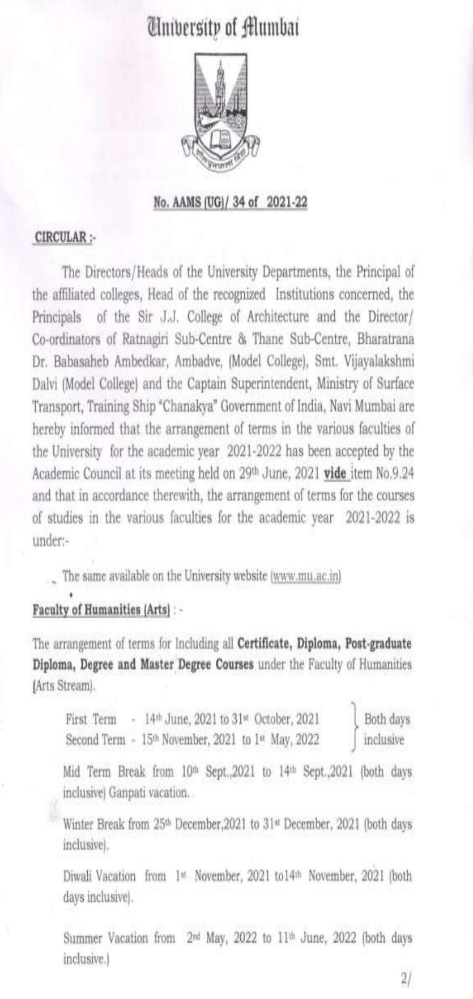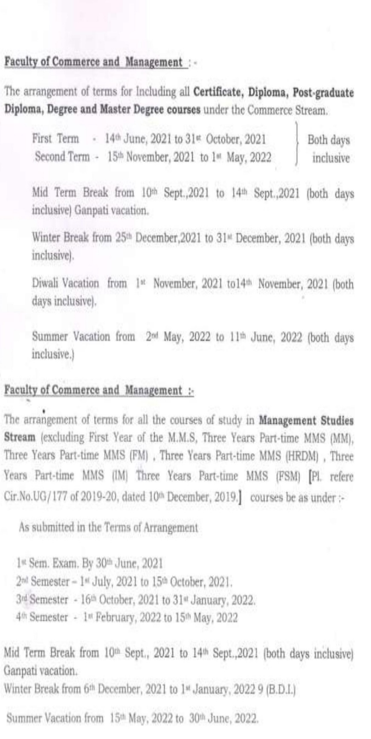

Academic Calendar of Institute 2021-2022
Date | Activities
12th June 2021, Saturday | Session and Mock Interview For students applied for Property pistol/ Career Guidance Session on “International Trends in Hospitality Industry and Management Education”
19th June 2021, Saturday | International Webinar on “Career Prospects of Management Education After Graduation”
27th June 2021, Sunday | Session & Mock Interview for Big Basket
29th June 2021, Tuesday | हम hoge कामयाब” Work Culture to Work Performance  (Session)
4th July 2021, Sunday | Guest Lecture
12th July 2021, Monday | Mock Interview
13th July 2021, Tuesday | Mock Interview
16th July 2021, Friday | Mock Interview
22nd July 2021, Thursday | Webinar – “Angel/Investment/VC Funding Opportunity Of Early Stage Entrepreneurs’’
28th July 2021, Wednesday | Session & Mock Interview for Reliance Jio
3rd August 2021, Tuesday | Session for Operations students
7th August 2021, Saturday | A visit to RAYAT INCUBATION CENTER
15th August 2021, Sunday | Independence Day (Holiday)
17th To 21st August, Tuesday - Saturday | MMS Mid Semester-II(2020-2022)
27th August 2021, Friday | “INTELLECTUAL PROPERTY RIGHTS AND IP MANAGEMENT” (Session)
16th September 2021, Thursday | International Ozone Day Celebration
25th September 2021, Saturday | A session on “Developing Reading Habits”
27th To 29th September 2021, Monday - Wednesday | “Warehouse Supervisor”(Lecture Series)
2nd October 2021, Saturday | Gandhi Jayanti (Holiday)
5th To 6th , 8th To 9th, 11th To 14th October 2021 | End Semester MMS-II (2020-2022)
21st – 22nd October 2021, Thursday - Friday | International Conference on Circular, Economy, Management and Industry 4.0 Leading toward sustainability
23rd October 2021, Saturday | Commencement of MMS Semester-III
25th October 2021, Monday | IPR Lecture Series
1st to 7th November 2021 Monday - Sunday | Diwali Vacation (Holiday)
18th November 2021, Thursday | Patents-Workshop
20th November 2021, Saturday | Mock Interview
4th December 2021, Saturday | Guest Lecture
15th – 18th December 2021 | Mid Term Exam Semester III
25th December 2021, Saturday | Christmas (Holiday)
1st January 2022, Saturday | Guest Lecture
6th January 2022, Thursday | Induction Progamme MMS Semester I
15th January 2022, Saturday | Mock Interview
17th – 24th January 2022 | End Term Exam Semester III
22nd January 2022, Saturday | Guest Lecture
26th January 2022, Wednesday | Republic Day (Holiday)
29th January 2022, Saturday | Mock Interview
5th February 2022, Saturday | Guest Lecture
9th February 2022, Wednesday | National Webinar Financial Education on Opportunity &Innovation in Indian capital Market
12th February 2022, Saturday | Guest Lecture
21st February 2022, Tuesday | Matrubhasha Divas (Mother Language Day)
26th February 2022, Saturday | Mock Interview
26th February 2022, Saturday | Mindful (Yoga) Session
1st March 2022, Tuesday | Mahashivratri (Holiday)
5th March 2022, Saturday | Guest Lecture
8th March 2022, Tuesday | Investor Awareness Program specially for Women
12th March 2022, Saturday | Mock Interview
18th March 2022, Friday | Dhulivandan (Holiday)
19th March 2022, Saturday | Webinar
26th March 2022, Saturday | Mock Interview
2nd April 2022, Saturday | Gudi Padwa
9th April 2022, Saturday | Mock Interview
14th April 2022, Thursday | Dr. Babasaheb Ambedkar Jayanti (Holiday)
15th April 2022, Friday | Good Friday (Holiday)
16th April 2022, Saturday | Mock Interview
23rd April 2022, Saturday | Guest Lecture
3rd May 2022, Tuesday | Eid-Ul-Fitra (Holiday)
7th May 2022, Saturday | Webinar
14th May 2022, Saturday | Budha Pournima (Holiday)
21st May 2022, Saturday | Guest Lecture
28th May 2022, Saturday | Mock Interview

c) Academic Time Table with the name of the Faculty members handling the course
MMS Semester I Division A (AY 2021-22) MMS Semester I Division B (AY 2021-22)
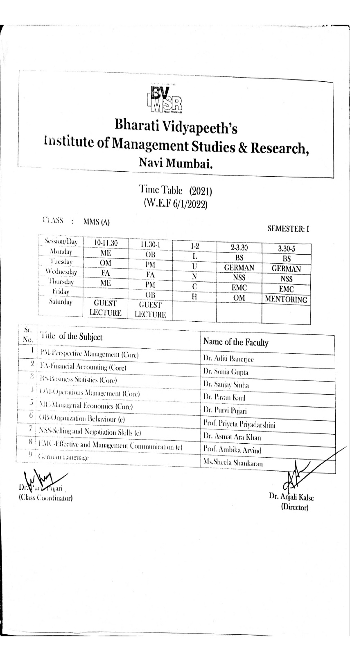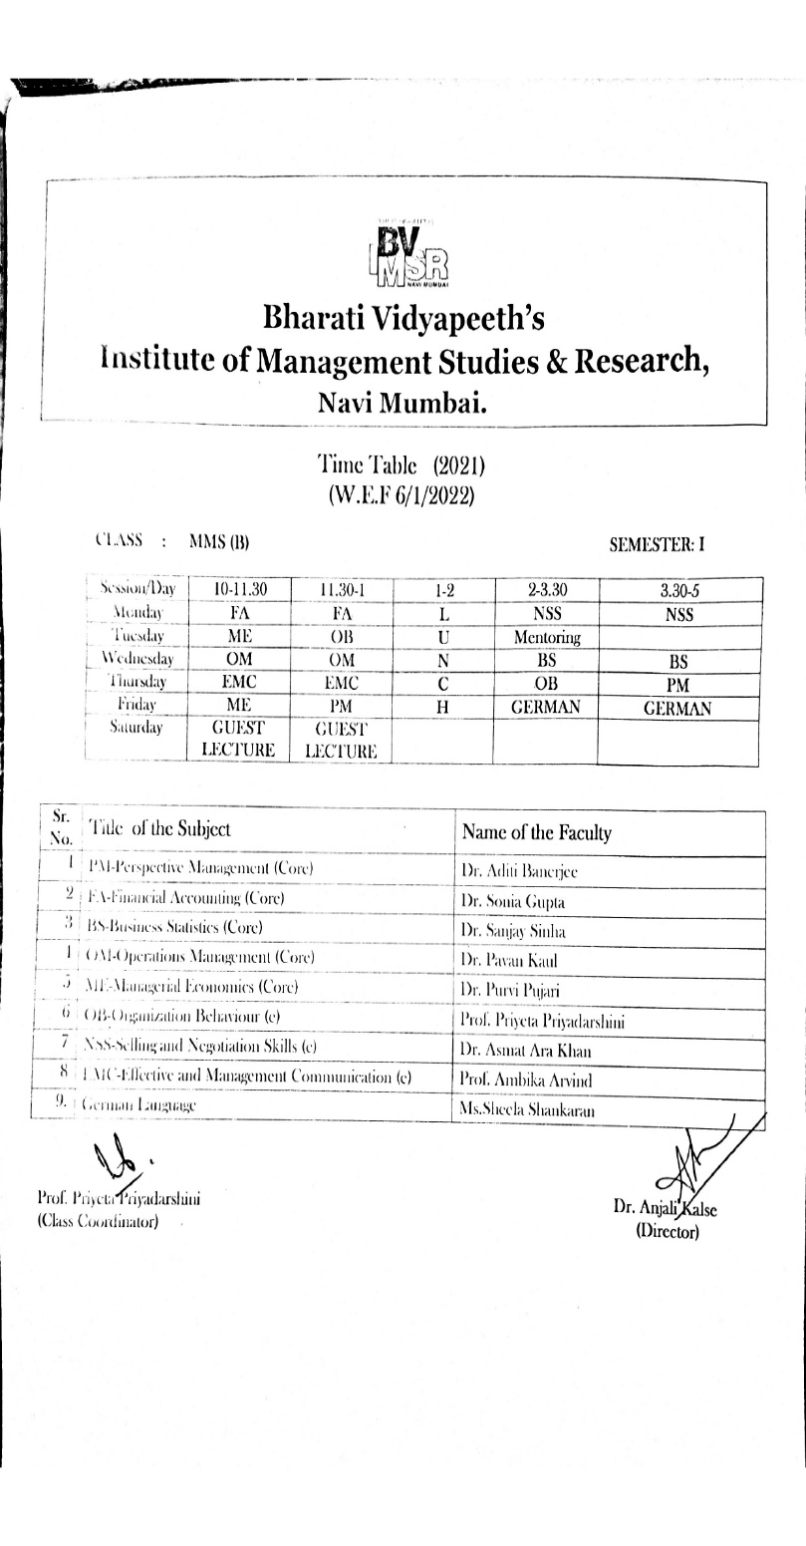

MMS Semester I Division C (AY 2021-22)
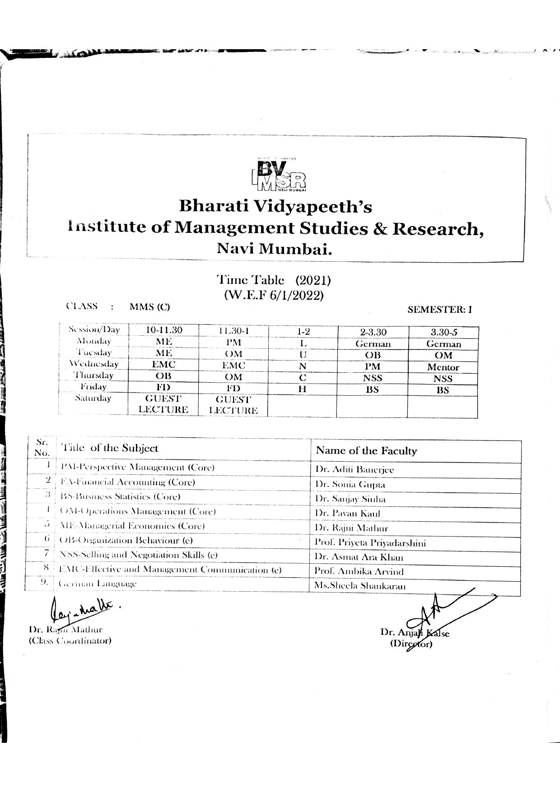

MMS Semester III (AY 2021-22)

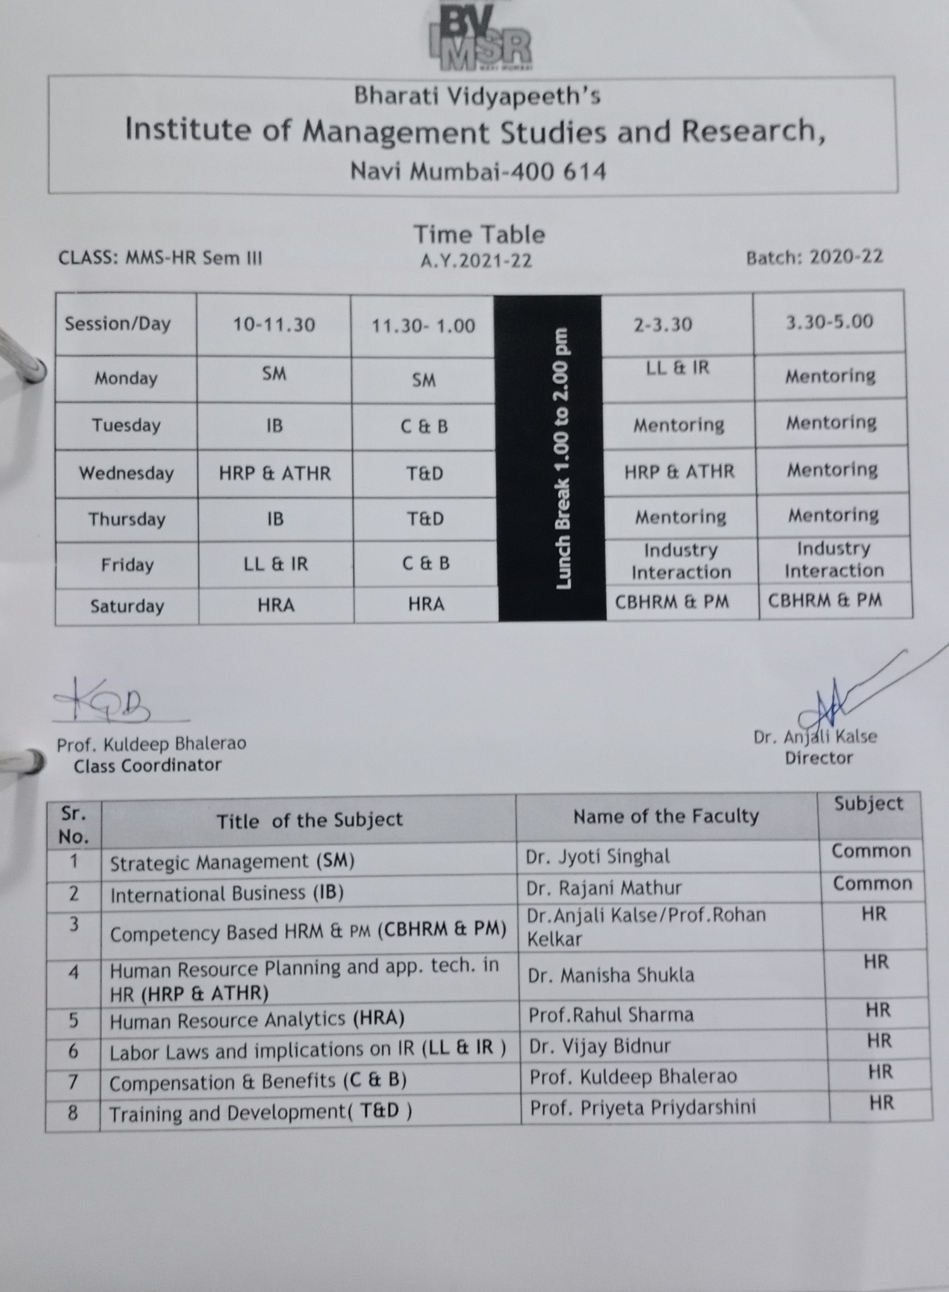

MMS – Operations Semester IV (AY 2021-22)

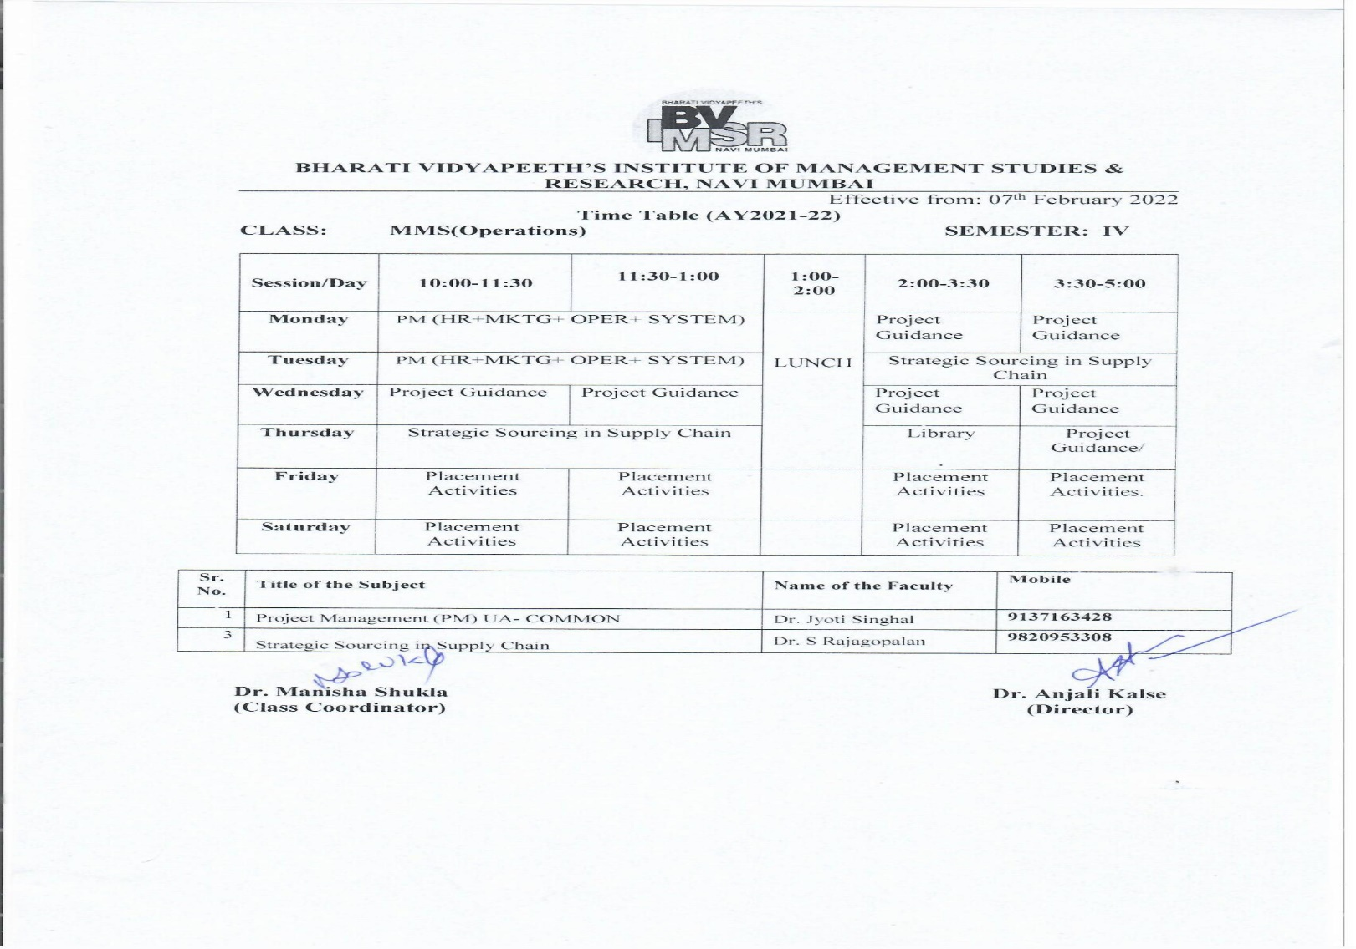
MMS – HR Semester IV (AY 2021-22) MMS – Systems Semester IV (AY 2021-22)
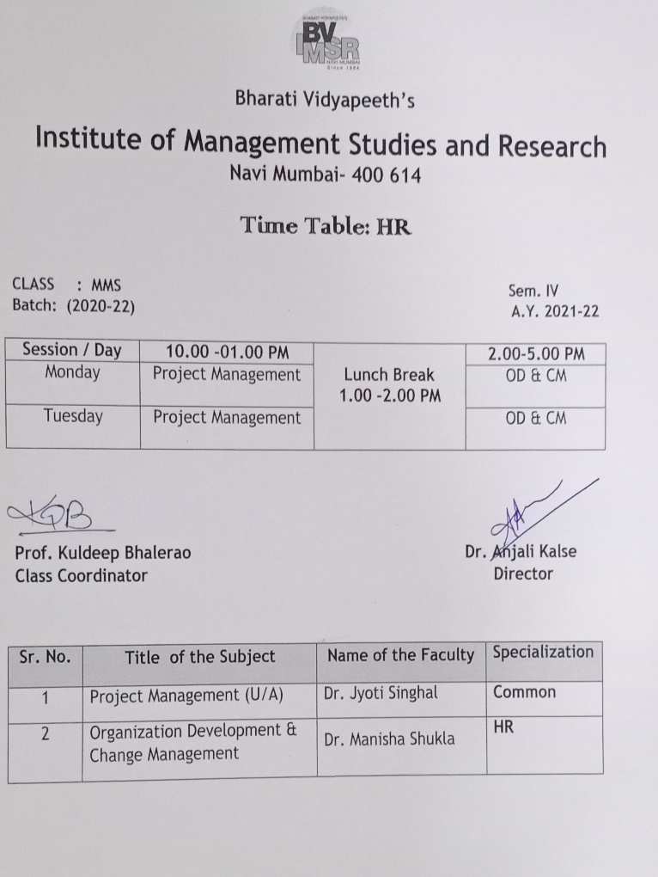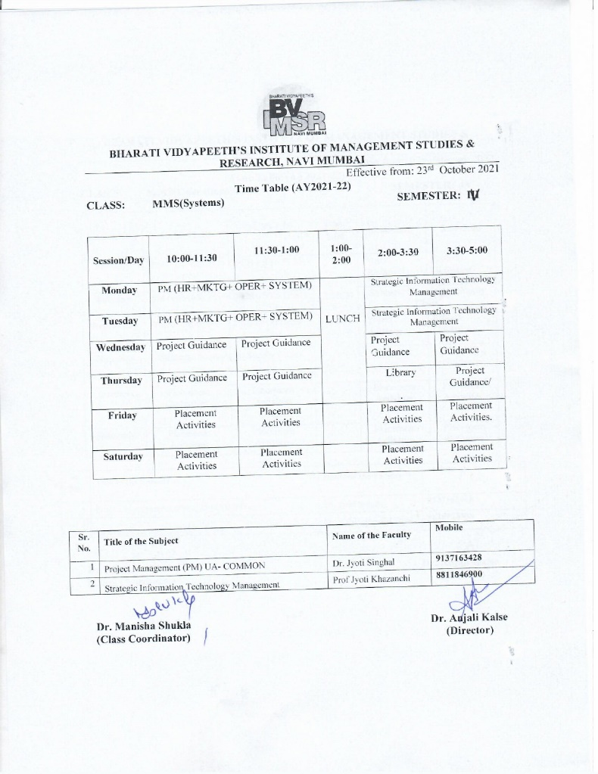

d) Teaching Load of each Faculty
Bharati Vidyapeeth's Institute of Management Studies amd Research Workload 2021
Name | Subject | Course | Marks | Actual/Effective Marks | Theory (In Hrs) | Total
Dr. Manisha Shukla | OD & Change Management | MMS Sem IV | 100 | 100 | 3 | 3
Ms. Priyeta Priyadarshini | Organizational Behaviour | MMS Sem I (A) (93 Students) | 100 | 100 | 3 | 6
Ms. Priyeta Priyadarshini | Organizational Behaviour | MMS Sem I (B) (94 Students) | 100 | 100 | 3 | 6
Ms. Sonali Athawale | Financial Accounting | MMS SEM I B | 100 | 100 | 3 | 6
Ms. Sonali Athawale | Financial Accounting | MMS Sem I (C) | 100 | 100 | 3 | 6
Ms. Alka Dhingra | Financial Accounting | MMS A for 90 students | 100 | 100 | 3 | 6
Ms. Alka Dhingra | Commercial Banking | MMS sem IV | 100 | 100 | 3 | 6
Dr. Veena Tripathi | Integrated Marketing Communication | MMS final Year Marketing | 100 | 100 | 4 | 7
Dr. Veena Tripathi | Operations Management | MMS A first year | 100 | 100 | 3 | 7
Dr. Asmatara Khan | Negotiation & Selling Skills | MMS-A, SEM-I | 100 | 100 | 3 | 6
Dr. Asmatara Khan | Negotiation & Selling Skills | MMS-B SEM-I, | 100 | 100 | 3 | 6
Prof.Rajni Mathur | Managerial Economics | MMS Sem-I ( 93 Students ) | 100 | 100 | 3 | 3
Dr.Purvi Pujari | Managerial Economics | MMS Sem- I (94 Students) | 100 | 100 | 3 | 3

Bharati Vidyapeeth's Institute of Management Studies amd Research Workload 2021(Second Half)
Name | Subject | Course | Marks | Actual/Effective Marks | Theory (In Hrs) | Total
Dr. Manisha Shukla | Business Research Methodology | MMS B Sem-II (94 Students) | 100 | 100 | 3 | 3
Ms. Priyeta Priyadarshini | Human Resource Management | MMS A Sem-II (93 Students) | 100 | 100 | 3 | 6
Ms. Priyeta Priyadarshini | Human Resource Management | MMS B Sem-II (94 Students) | 100 | 100 | 3 | 6
Ms.Veena Kolte | Financial Management | MMS A Sem-II (93 Students) | 100 | 100 | 3 | 6
Ms.Veena Kolte | Financial Management | MMS B Sem-II (94 Students) | 100 | 100 | 3 | 6
Dr. Asmatara Shaikh | Business Research Methodology | MMS A Sem-II (93 Students) | 100 | 100 | 3 | 3
Prof. Sameer Sonawane | Marketing management ( Application-based ) | MMS A Sem-II ( Mark. Stud. ) | 100 | 100 | 3 | 3
Prof. Sameer Sonawane | Marketing management ( Application-based ) | MMS B Sem-II( Mark. Stud. ) | 100 | 100 | 3 | 3
Dr. Rajni Mathur | Entrepreneurship Management | MMS B Sem-II (94 Students) | 100 | 100 | 3 | 6
Dr. Rajni Mathur | Business Environment | MMS A Sem-II (93 Students) | 100 | 100 | 3 | 6
Dr.Purvi Pujari | Entrepreneurship Management | MMS A Sem-II (93 Students) | 100 | 100 | 3 | 6
Dr.Purvi Pujari | Business Environment | MMS B Sem-II (94 Students) | 100 | 100 | 3 | 6
Dr. Manisha Waghmode | Operations Research | MMS B Sem-II (94 Students) | 100 | 100 | 3 | 3
Dr. Manisha Waghmode | Summer Internship Project | MMS SEM III | 100 | 100 | 4 | 4

Bharati Vidyapeeth's Institute of Management Studies amd Research Workload 2022(First Half)
Name | Subject | Course | Marks | Actual / Effective Marks | Theory (In Hrs) | Total
Dr. Makarand Pole | Placement Responsibility
Dr. Manisha Shukla | OD & CM | MMS Sem IV | 100 | 100 | 3 | 10
Ms. Priyeta Priyadarshini | Organizational Behaviour | MMS-A | 100 | 100 | 3 | 9
Ms. Priyeta Priyadarshini | Organizational Behaviour | MMS-B | 100 | 100 | 3 | 9
Ms. Priyeta Priyadarshini | Organizational Behaviour | MMS-C | 100 | 100 | 3 | 9
Dr. Sanjay Sinha | Business Statistics | MMA - A, B & C | 100 | 100 | 3 x 3 | 14.5
Dr. Sanjay Sinha | Commercial Banking | MMS Sem IV | 100 | 100 | 3 | 14.5
Dr. Sanjay Sinha | Research Methodology | PhD | 100 | 100 | 2.5 | 14.5
Dr. Sonia Gupta | Financial Accounting | MMS-A | 100 | 100 | 3 | 9
Dr. Sonia Gupta | Financial Accounting | MMS-B | 100 | 100 | 3 | 9
Dr. Sonia Gupta | Financial Accounting | MMS-C | 100 | 100 | 3 | 9
Dr. Jyoti Singhal | Project Management | MMS Sem IV | 100 | 100 | 3 | 6
Dr. Jyoti Singhal | Project Management | MMS sem IV | 100 | 100 | 3 | 6
Dr. Asmat Ara Shaikh | Selling and Negotiation Skills | MMS-A | 100 | 100 | 3 | 9
Dr. Asmat Ara Shaikh | Selling and Negotiation Skills | MMS-B | 100 | 100 | 3 | 9
Dr. Asmat Ara Shaikh | Selling and Negotiation Skills | MMS-C | 100 | 100 | 3 | 9
Dr. Rajni Mathur | Managerial Economics | MMS C | 100 | 100 | 3 | 3
Dr.Purvi Pujari | Managerial Economics | MMS-A | 100 | 100 | 3 | 6
Dr.Purvi Pujari | Managerial Economics | MMS-B | 100 | 100 | 3 | 6
Dr. Aditi Banerjee | Perspective MAnagement | MMS-A | 100 | 100 | 3 | 12
Dr. Aditi Banerjee | Perspective MAnagement | MMS-B | 100 | 100 | 3 | 12
Dr. Aditi Banerjee | Perspective MAnagement | MMS-C | 100 | 100 | 3 | 12
Dr. Aditi Banerjee | Integrated Marketing Communication | MMS Sem IV | 100 | 100 | 3 | 12

e) Internal Continuous Evaluation System and place
In order to ensure Quality of continuous assessment and evaluation processes, Institute follows University of Mumbai syllabus.
The University of Mumbai syllabus applicable for the different academic years is Credit Based semester and Grading System (Choice Based)(CBCGS)
- Restructured & Revised Syllabus under CBCGS (Choice based Credits and Grading System) for MMS Effective from the academic year 2016–2017.
Scheme of Assessments for Subjects of 100 Marks
- Semester end Examination will be conducted for 60 Marks
- Internal Assessments will be conducted for 40 Marks.
The allocation of 40 marks shall be on the following basis: -
- Attendance and Class Room Participation 10 Marks
- Midterm Test (Min 1)
- Minimum 2 criteria to be picked up from the below given list
- Group Presentations
- Role Plays
- Case Studies
- Assignments
- Projects
- Quizes
Table 3.1.1 A: Format for collection of Internal Marks
Bharati Vidyapeeth's Institute of Management Studies and Research
Break up of Internal Marks Assessment for 40 marks ( for 100 Marks Subject)
Course &Div: ________ Semester :_____ |  |  |  |  | BATCH : _____________
Subject:________________________ |  |  |  |  | Specialization :________________
Roll No | Name of the Student | Mid Term Test | Criteria 1 | Criteria 2 | Criteria 3 | Criteria 4 | Criteria 5 | TOTAL Internal Marks
Roll No | Name of the Student | Mid Term Test | Weightage for Test | Attendance |  |  |  | TOTAL Internal Marks
Roll No | Name of the Student | 20 Marks | 10 Marks | 10 Marks | 10 Marks | 10 Marks | Marks | 40 MARKS
Name of The Faculty:______________________ Signature with Date :______
Note: Minimum 3 criteria to be picked up from the below list for weightage of 20 marks as applicable to the subject and the chosen criteria to be mentioned in above sheet.
1 | Group Presentation
2 | Role Plays
3 | Case Studies
4 | Assignments
5 | Projects
6 | Quiz

- Test: This type of performance assessment is carried out during the internal examination session which is held once a semester (Mid Term Test). Each and every session is focused on attaining the course outcomes.
Assessment process:
- Test is conducted
- Paper assessment.
- Record of test marks in the format as per Table 3.1.1.A.
- Question paper discussion in class
- The assessed answer sheets are shown to the students for verification.
- Students are counseled accordingly.
- Evaluation of COs attainment.
- COs attainment analysis submitted to Academic Advisory Board (AAB)
- Academic Advisory Board (AAB) suggests further action to concerned course owners.
- Submission of marks to exam cell.
- Assignments are given on regular basis to assess course outcomes.
  - Assignments are assigned to students.
  - Marks weightage is assigned to the assignments given by the course owners.
  - Evaluation of COs attainment.
  - COs attainment analysis submitted to Academic Advisory Board(AAB)
  - Academic Advisory Board (AAB) suggests further action to the concerned course owners.
  - Submission of compiled marks of assignment (calculations as per the course evaluation scheme) to exam cell.

Note: Internal Assessment (IA) and End Semester Examination (ESE) should be two separate heads for passing. E.g. 40 marks (IA), 60 marks (ESE). Passing standard will be 50% in each individually, i.e 20 marks in (IA) and 30 marks in ESE.
- Process for internal semester question paper setting and evaluation and effective process implementation
Question Paper setting and evaluation: As per the guidelines of University of Mumbai, Question papers are set internally for internal assessment (IA) subjects. The paper setters and evaluators, moderators either internal or external are appointed by the chief conductor on the basis of subject knowledge and experience of the faculties. For University assessment (UA) subjects, the paper setters and evaluators, moderators are appointed by the University of Mumbai. The papers are evaluated/moderated in a Centralized Assessment Process (CAP).
- Process to ensure questions from outcomes/learning levels perspective
For effective process implementation a standard question paper format is followed. From Academic year 2017-18 faculty is instructed to set question paper to cover all course outcomes(CO) and learning levels(LL) perspective by using Bloom’s Taxonomy.
- Evidence of COs coverage in class test / mid-term tests
From Academic year 2017-18 the faculty is instructed to maintain the evidence of COs coverage in class test / mid-term tests in their respective course file.
- Quality of Assignment and its relevance to COs
From Academic year 2017-18 the faculty is instructed to maintain the details related to Quality of Assignment and its relevance to CO’s in their respective course file.

f) Student assessment of Faculty, System in place

Student feedback of teaching learning process and actions taken:
Feedback collection process for AY 2017-18 to AY 2019-20
There is a robust feedback mechanism to evaluate course teachers by the students. A LAN based tailor made software ‘Faculty Feedback System’ is used to collect the feedback from the students in Institute’s computer laboratory.
All students of each class are given an opportunity to express their opinion with regards to effectiveness in teaching by the faculty, which are detailed in the feedback format. Anonymity is maintained so students are able to freely give feedback.
Feedback reports are generated by the software, it includes the percentage score of every parameter and the overall performance percentage.
Student’s feedback about the teaching-learning processes is collected semester wise on a five –point scale.
- Outstanding ---5 points
- Very Good---4 points
- Good ---3 points
- Need Improvement---2 points
- Need Lot of Improvement---1 point
Feedback is sought on parameters such as:
1 | Passion & enthusiasm to teach
2 | Subject knowledge
3 | Clarity & Emphasis on concepts
4 | Motivating, inspiring & promoting student thinking
5 | Coverage of syllabus as per academic planning
6 | Quality of illustrative visuals examples & applications
7 | Regularity & Punctuality
8 | Discipline & control over the class
9 | Notes & reading material provided
10 | Regular assessment, revision and discussion of question papers

The Reports also include the overall performance of the above 10 parameters.
For every class, for all subjects, the percentage of the average scores given by all the students for each of the ten feedback criteria is computed. In case a subject is shared by two or more faculties feedback for both the faculties is taken.
The percentage for each of the 10 criteria is calculated. Also, the percentage of the average of all these feedback parameters is computed which is taken as the overall performance for that particular faculty. The percentage of every parameter and overall performance calculation is automated to avoid manual mistakes.
A consolidated report is generated for each class showing the criteria wise details for each faculty teaching in the class
Student’s feedback is not restricted to the above parameters. The students can also give their comments on varied areas.
Analysis: The feedback report is submitted to the Director. A list of faculties who have scored less than 60 % in overall performance is prepared. Similar list is prepared for the faculties whose overall performance is above 90%.
Actions Taken: The feedback is shared with the concerned faculty by theDirector, to take corrective measures.
The following actions are taken on basis of the feedback collected.
Commendatory actions:
Appreciation letter is given to the faculty members having feedback 90% and above.
Corrective actions taken:
Faculties receiving overall percentage of feedback above 50 % to below 60 % are counseled by Director.
Faculties receiving overall percentage of feedback below 50 % are counseled by Director and given improvement letters.

Feedback collection process:from AY 2020-21
There is a vigorous feedback mechanism to evaluate course teachers by the students. Till the academic year 2019-20 Institute used to use LAN-based tailor-made software ‘Faculty Feedback System’ to collect the feedback from the students in Institute’s computer laboratory. However, due to COVID 19 pandemic, from the academic year 2020-21 shifted to online classes. Since to students are unable to report to the institute physically to give feedback, so Institute deployed Google form-based feedback system. We organize online meetings and share Google form for collecting feedback from students.
All students of each class are allowed to express their opinion with regards to the effectiveness in teaching pedagogy of the faculty, which is detailed in the feedback format. Anonymity is maintained so students can freely give feedback.
Feedback reports are generated in Google form; it includes the percentage score of every parameter and the overall performance percentage.
Student’s feedback about the teaching-learning processes is collected semester-wise on a five-point scale. Poor= 02, Fair= 04, Average = 06, Good= 08, Excellent= 10
- Excellent = 10 points
- Good---08 points
- Average ---06 points
- Fair---04 points
- Poor---- 02 point
Feedback is sought on parameters such as:
1 | Subject Knowledge
2 | Syllabus Completion
3 | Study Material- PPT, online material etc.
4 | Conducting lecture on time
5 | Communication Skills
6 | Motivation & Enthusiasm during lecture
7 | Practical Exposure- Case Study, business updates and ad on working knowledge
8 | Encouraging / Motivating Academic Interaction
9 | Discipline and Approachability
10 | Overall Lecture Quality

The Reports also include the overall performance of the above 10 parameters.
For every class, for all subjects, the percentage of the average scores given by all the students for each of the 10 feedback criteria is computed. In case a subject is shared by two or more faculties feedback for both the faculties is taken.
The percentage for each of the 10 criteria is calculated. Also, the percentage of the average of all these feedback parameters is computed which is taken as the overall performance for that particular faculty. The percentage of every parameter and overall performance calculation is automated to avoid manual mistakes.
A consolidated report is generated for each class showing the criteria wise details for each faculty teaching in the class
Student’s feedback is not restricted to the above parameters. The students can also give their comments on varied areas.
Analysis: The feedback report is submitted to the Director. A list of faculties who have scored less than 60 % in overall performance is prepared. Similar list is prepared for the faculties whose overall performance is above 90%.
Actions Taken: The feedback is shared with the concerned faculty by the Director, to take corrective measures.
The following actions are taken on basis of the feedback collected.
Commendatory actions:
Appreciation letter is given to the faculty members having feedback 90% and above.
Corrective actions taken: Faculties receiving overall percentage of feedback above 50 % to below 60 % are counseled by Director.
Faculties whose overall percentage of feedback below 50 % are counseled by Director, issued letter for improvement and suggest suitable online and offline courses.

16. Enrolment and placement details of students in the last 3years
Enrollment Details:
Category | Year 2021-22 |  |  | Year 2020-21 |  |  | Year 2019-20
Category | M | F | T | M | F | T | M | F | T
State Quota | 37 | 45 | 82 | 02 | 06 | 08 | 21 | 22 | 43
Outside State Quota | 02 | 03 | 05 | 09 | 01 | 10 | 05 | 01 | 06
NRI Quota | 00 | 00 | 00 | 00 | 00 | 00 | 00 | 00 | 00
PIO/Foreign National | 00 | 00 | 00 | 00 | 00 | 00 | 00 | 00 | 00
SC/ST/OBC/NT/VJ | 33 | 24 | 57 | 21 | 16 | 37 | 24 | 22 | 46
J&K Quota | 00 | 00 | 00 | 00 | 00 | 00 | 01 | 00 | 01
Management Quota | 14 | 22 | 36 | 50 | 72 | 122 | 09 | 15 | 24
EWS Seats | 04 | 01 | 05 | 05 | 02 | 07 | 01 | 00 | 01
TFWS Seats | 03 | 01 | 04 | 04 | 01 | 05 | 00 | 00 | 00
Total admission | 93 | 96 | 189 | 91 | 98 | 189 | 61 | 60 | 121

Placement Details:
Year | 2020-21 | 2019-20 | 2018-19
Non-IT | 07 | 85 | 49
IT | 77 | 03 | 09

17. List of Research Projects/ Consultancy Works
• Number of Projects carried out, funding agency, Grant received
Name of the Project | Funding Agency | Grant Received (in Rs.)
Impact of e-resources on the reading habits ofgraduate students” | ICSSR | Rs. 8,40,000/-
The Influence of Internet Exposure on Children’s Development, Behavior & Learning | IMPRESS- ICSSR | Rs. 5,00,000/-
Issues in Designing & Sustainability of MOOC:  Learning Analytical Model | ICSSR | Rs. 10,00,000/-
A Comprehensive study on Employability Skills  and Pedagogy adopted by Management Institutes in India | University of Mumbai | Rs. 30,000/-
A Study Of Factors Affecting The Perception Of Undergraduate Students Towards Selection Of Post Graduate Management Courses Under Mumbai University | University of Mumbai | Rs. 26000/-
Faculty Attrition: A Study Of Management Institutes Affiliated To Mumbai University | University of Mumbai | Rs. 24,000/-

Faculty Research Publications

Sr.  No. | Name of Faculty | Name of Refereed Journal | Nation al / Interna tional | Title of the Paper | Year of Publication | ISSN / ISBN | UGC/  Referred/ ABDC/  Scopus/ WOS | Status | Indexing
1 | Dr.Anjali Kalse | Novyi Mir Research Journal | Internat ional | ”A review on micro insurance in rural India | 2021 | ISSN No:- 0130-7673  .Impact factor 6.1 | UGC  approved | Done | WOS
2 | Dr.Anjali Kalse | Revista Geintec- Gestao Inovacao E Tecnologias | Internat ional | An Exploration of The Internet Influence Amongst School  Going Children | 2021 | 2237-0722 | Web of Science | Done | WOS
3 | Dr. Manisha Shukla | Revista Geintec- Gestao Inovacao E Tecnologias | Internat ional | An Exploration of The Internet Influence Amongst School  Going Children | 21-Jun | 2237-0722 | Web of Science | Done | WOS
4 | Dr. Manisha Shukla | Journal of Contemporary Issues in Business and Government | Internat ional | An Exploratory Study On Motives And Use Of Electronic Resources By  Graduate Students In Navi Mumbai | Feb. 2021 | 1323-6903 | Web of Science | Done | WOS
5 | Dr.V.V.Bid nur | Vidyabharti International Interdisciplinary | Internat ional | A Study on the gaining popularity of E-commerce during COVID-19 Pandemic :- A Case Study of Navi Mumbai | Special Issue:- Augest 2021 | ISSN23 19-4979  Impact Factor :- 1.469  (2020-2021) | Web of Science | Done | WOS
6 | Dr.V.V.Bid nur | Novyi Mir Research Journal | Internat ional | ”A review on micro insurance in rural India | Jun-21 | ISSN No:- 0130-7673  .Impact  factor 6.1 | UGC  approved | Done | UGC
7 | Prof Veena Kolte | Academy of Marketing  Studies Journal | Internat ional | Sufferings And Pain Of Retired (Old) Aged People During  Covid-19: A Case Of Indian Family | Jun-21 | 1528-  2678-25-4-444 | ABDC | Done | ABDC
8 | Prof. Kuldeep Bhalerao | Asian Journal of Management | Nationa l | Impact of COVID 19 on small and medium  enterprises | Vol. 3,  Issue 1,  2022 | 2321-5763 | Referred & Indian Citation  Index | Done | Others
9 | Prof. Kuldeep  Bhalerao | Academy of Marketing  Studies Journal | Internat ional | Technology: A pathway towards  sustainability | 2021 | 1528-2678 | ABDC- B  Category | Done | ABD C

10 | Prof. Kuldeep Bhalerao | Business Studies Journal | Nationa l | Covid 19 pandemic: changing business  model. | 2021 | 1944-6578 | Referred | Done | Othe rs
11 | Prof. Kuldeep  Bhalerao | NOVIY MIR  Research Journal | Nationa l | A Review on Micro Insurance  in Rural India. | 2021 | 0130-7673 | Web of Science | Done | WOS
12 | Dr. Asmat Ara | Journal of Contemporary Issues in Business and Government Vol. 27, No. 2,  2021 | Internat ional | An Exploratory study on Motives and use of Electronic Resources by Graduate Students  in Navi Mumbai | 2021 | ISSN: 1323-  6903 | Web of Science | Done | WOS
13 | Dr. Asmat Ara | Academy of Marketing Studies Journal, Volume 25,  Issue 03, 2021 | Internat ional | “A two-decade literature review on challenges faced by SMEs in technology  adoption” | 2021 | ISSN: 1528-  2678 | ABDC_ B | Done | ABD C
14 | Dr. Asmat Ara | Academy of Marketing Studies Journal, Volume 25,  Special Issue 2,  2021 | Internat ional | “A viewpoint on sustainable practices of Coles and Woolworths during covid-19” | 2021 | ISSN: 1528-  2678 | ABDC_ B | Done | ABD C
15 | Dr. Asmat Ara | Academy of Strategic Management Journal Volume 20, Special Issue  5, 2021 | Internat ional | “Role of Emotional Intelligence and strategic human resource management during covid-19 pandemic” | 2021 | ISSN: 1939-  6104 | SCOPU S | Done | Scop us
16 | Dr. Asmat Ara | Journal of Contemporary Issues in Business and Government Vol. 27, No.  2,2021, | Internat ional | “Empirical study: Influence of trade value offered by e-marketers on  intention quotient of Mumbai based online shoppers to  shop online” | 2021 | ISSN: 1323-  6903 | Web of Science | Done | WOS
17 | Dr. Asmat Ara | Materials Today proceeding SCOPUS  Indexed, 10.1016/j.matpr. 2021.07.388 | Internat ional | “The aspect of Vast data management problem in healthcare sector and implementation of cloud computing  techniques” | 2021 |  | SCOPU S | Done | Scopus
18 | Prof. Priyeta Priyadarshi ni | Vidyabharathi International Interdisciplinary Research Journal | Internat ional | A study on the gaining popularity of E-commerce during Covid-19 Pandemic:A case study of Navi-  Mumbai | 2021 | 2319-  4979 | Web of Science | Done | WOS
19 | Prof. Priyeta Priyadarshi ni | Dogo Rangrang Research Journal | Nationa l | Facilities To Prospective Patients With  Reference To Dawaibox” | 2021 | 2347-  7180 | UGC | Done | UGC
20 | Prof. Priyeta Priyadarshi ni | Dogo Rangrang Research Journal | Nationa l | A Study Of Impact Of Web Series Streaming Online On Indian  Youth | 2021 | 2347-  7180 | UGC | Done | UGC

21 | Prof. Priyeta Priyadarshi ni | Peer Reviwed Journal (CPI- Ahmedabad) | Internat ional | Attitudinal, Awareness and Perceptional differences in Virtual and Offline learning during COVID-19  Pandemic | 2021 | In progress |  | 2  COPI ES PEN DING | Othe rs
22 | Prof. Sameer Sonawane | Quest Journals Journal Of Research In  Business And Management | Internat ional | Does Online / App-Based Pharmacy Impact  India To Lower Health Cost? | 2021 | 2347-  3002 | crossref | Done | Othe rs
23 | Prof. Manisha Waghmode | Journal of Contemporary Issues in Business and Government Vol. 27, No. 2,  2021 | Internat ional | An Exploratory study on Motives and use of Electronic Resources by  Graduate Students in Navi Mumbai | 2021 | ISSN: 1323-  6903 | Web of Science | Done | WOS
24 | Prof. Manisha Waghmode | Revista Geintec- Gestao Inovacao E Tecnologias | Internat ional | An Exploration of The Internet Influence  Amongst School Going Children | 2021 | 2229-3620 | WOS | Done | WOS
25 | Prof.SatyaS  .Ranjan | Vidyabharati International Interdisciplinary Research Journal Special issue | Internat ional | A study on the gaining popularity of E-commerce during COVID-19 pandemic: A case study of Navi  Mumbai | August. 2021 | ISSN: 2319-  4979 |  | Done | WOS
26 | Dr. Asmat Ara | Business Studies Journal | Internat ional | Significance of Radio Frequency Identification Device (RFID) In the Transit Sector | 2021 | Print ISSN: 1944-656X;  Online ISSN: 1944-  6578) | ABDC- C | done | Scop us
27 | Dr. Anjali Kalse | Dogo Rangsang Research Journal | Nationa l | Factors Affecting The Perception Of Undergraduate Students Towards Institute Parameters For Selection Of Post Graduate Management Institutes Under Mumbai  University | 2020 | 2347-  7180 | UGC | done | UGC
28 | Dr. Anjali Kalse | Dogo Rangsang Research Journal | Nationa l | Understanding Factors Impacting The Choice Of Undergraduate Students For Selection Of Post Graduate Management Institutes Under Mumbai University – On The Basis Of Academic Result, Examination System,  Accreditation Of The Institute And Fee Structure Of  The Institute | 2020 | 2347-  7180 | UGC | Done | UGC

2  9 | Dr. Anjali Kalse | BVIMSR's  Journal of Management Research | Nationa l | A Study of Factors related to Placement in Affecting the Perception of Undergraduate Students towards Selection of Post Graduate Management Courses under  Mumbai University | 2020 | 0976-4739 | UGC | Done | UGC
3  0 | Dr. Anjali Kalse | Materials Today | Internat ional | Usage and adoption of artificial intelligence in  SMEs | 2021 | 2214-7853 | SCOPU S | 2 COPI ES  PEN DING | Scop us
3  1 | Dr. Manisha Shukla | Pyschology and Education | Internat ional | A Study of Electronic Resources and Reading Habit of Graduate Students:  Hypothetical Framework | 2020 | ISSN: 0033-  3077 | SCOPU S | Done | Scop us
3  2 | Dr. Manisha Shukla | Shodh Sanchar Bulletin An International Multidisciplinar y Quarterly bilingual peer reviewed referred research  Journal | International | Internet Usage and its influence on Children Development | 2020 | ISSN- 2348-  2397 | UGC | Done | UGC
3  3 | Dr. Manisha Shukla | Shodh Sarita An International Multidisciplinar y Quarterly bilingual peer reviewed  referred research Journal | International | A Study on the Inﬂuence of Internet Exposure on Children’s Behavior | 2020 | ISSN- 2348-  2397 | UGC | Done | UGC
3  4 | Dr.V.V.Bidnur | IJCRT | Internat ional | A Study on customer satisfaction of LIC policies with special reference to Miraj branch Dist.:- Sangli (Maharashtra) | Volum e 9, Issue 4 April  2021 | ISSN: 2320-  2882 |  Impact factor:  7.97 | | Peer Review Journal Refereed  Journal | Done | UGC
3  5 | Dr. Veena Tripathi | BVIMSR's  Journal of  Management Research | National | Punishing Signal : Honk More, Wait More | 2020 | ISSN: 0976 -  4739 |  | Done | Others
3  6 | Dr. Purvi Pujari | Dogo Rangsang Research Journal | National | Atmanirbhar Bharat: A Possibility or Dream | 2020 | 2347-7180 | UGC | Done | UGC
3  7 | Dr. Purvi Pujari | Dogo Rangsang Research Journal | Nationa l | Understanding Factors Impacting The Choice Of Undergraduate Students For Selection Of Post Graduate Management Institutes Under Mumbai University – On The Basis Of Academic Result, Examination System, Accreditation Of The Institute And Fee Structure Of The Institute | 2020 | 2347-  7180 | UGC | Done | UGC
3  8 | Dr. Purvi Pujari | Dogo Rangsang Research Journal | National | Factors Affecting The Perception Of Undergraduate Students Towards Institute Parameters For Selection Of Post Graduate Management Institutes Under Mumbai University | 2020 | 2347-7180 | UGC | Done | UGC
3  9 | Dr. Purvi Pujari | BVIMSR's  Journal of Management Research | National | A Study of Factors related to Placement in Affecting the Perception of Undergraduate  Students towards Selection of Post Graduate Management Courses under Mumbai University | 2020 | 0976 -4739 | UGC | Done | Othe rs
4  0 | Dr. Purvi Pujari | The Scientific Journal for Economics and Management" | Internat ional | Artificial Intelligence: Technology 4.0 as solution for healthcare workers during COVID-19  pandemic | 2021 | ,ISSN 1212-  3285,  online 2336-  4297 | ABDC- C | Done | ABD C
4  1 | Prof. Makarand Pole | Journal of Contemporary Issues in Business and Government | Nationa l | Integrating CSR with Employer Branding Initiatives:Proposi ng A Model | 2021 | Print ISSN 2204-  1990,  Online ISSN:13 23-6903 | ABDC- C | Done | ABD C
4  2 | Prof. Makarand Pole | Shodh Sanchar Bulletin10(40) | Nationa l | The Covid-19 Impact on Higher education  Institutions | 2021 | ISSN:22 29-3620 | UGC  Listed journal | Done | UGC
4  3 | Prof. Kuldeep Bhalerao | International Journal of Management and Economics | Nationa l | A study of job seeker perspective towards various job portals: Special reference  to Navi Mumbai | 2021 | 2664-7079 | Referred | Done | Othe rs
4  4 | Prof. Kuldeep Bhalerao | International Journal of Research in Management | Nationa l | A study of barriers and benefits of ICT  adoption among SMEs | 2021 | 2664-8806 | Referred | Done | Othe rs
4  5 | Prof. Kuldeep Bhalerao | International Journal of Management and Commerce | Nationa l | Information and Communication Technology Adoption in Small and Medium Enterprises: Post COVID-19  Mantra of Success | 2021 | 2664-6854 | Referred | Done | Othe rs
4  6 | Dr. Asmat Ara | Psychology And Education | Internat ional | A Study of Electronic Resources and Reading Habit of Graduate Students: Hypothetical Framework | 2020 | ISSN: 1323-  6903 | SCOPU S | Done | Scop us
4  7 | Prof. Priyeta Priyadarshi  ni | Insight Management Review Journal | Nationa l | A Study on Eating Habits of Young Generation | 2020 | 2277-  5677 |  | Done | Othe rs
4  8 | Prof. Priyeta Priyadarshi  ni | Dogo Rangrang Research Journal | Nationa l | Atmanirbhar Bharat: A Possibility Or A Dream | 2020 | 2347-  7180 |  | Done | UGC
4  9 | Prof. Priyeta Priyadarshi  ni | MGM IMSR’s  Research  Journal “Sanchetna” | Nationa l | A study on Organizational Culture of Start-Up Companies | 2020 | 2279-  0314 |  | Done | Othe rs
5  0 | Prof. Sameer Sonawane | BVIMSR's  Journal Of Management Research | Nationa l | Has The Outbreak Of The Coronavirus Pandemic Impacted The Online Pharmacy In Serving The Nation Or Capitalization Of Business  Opportunities In India? | 2020 | 0976-  4739 |  | Done | Othe rs
5  1 | Dr.Uma Durgude | Shodh Sanchar Bulletin An International Multidisciplinar y Quarterly bilingual peer reviewed  referred research Journal | Internat ional | Internet Usage and its influence on Children Development | 2020 | ISSN- 2348-  2397 | UGC | Done | UGC
5  2 | Dr.Uma Durgude | Shodh Sarita An International Multidisciplinar y Quarterly bilingual peer reviewed referred research  Journal | Internat ional | A Study on the Inﬂuence of Internet Exposure on Children’s Behavior | 2020 | ISSN- 2348-  2397 | UGC | Done | UGC
5  3 | Prof. Manisha Waghmode | BVIMSR’s  Journal of Management Research | Internat ional | A Study on an extent of sensitivity between Indian GDP and IT  Industry | 2020 | 0976-  4739 |  | done | Othe rs
5  4 | Dr. Manisha Waghmode | Shodh Sarita | Internat ional | A Study on the Inﬂuence of Internet Exposure  on Children’s Behavior | 2020 | 2348-  2397 | UGC | Done | UGC
5  5 | Dr. Manisha Waghmode | Shodh Sanchar Bulletin | Internat ional | Internet Usage and its influence on Children  Development | 2020 | 2229-  3620 | UGC | Done | UGC
5  6 | Dr.  Manisha Waghmode | Psychology and Education | Internat ional |  |  |  |  | A | UGC
5  8 | Prof. Anuj Kumar | PIMT Journal of Research | Internat ional | Comparison of Indian and New Zealand Leadership during  COVID-19 | Octobe r'2020 | ISSN: 2278-  7925 | UGC CARE | 1  copy requir ed | UGC
5  9 | Prof. Anuj Kumar | PIMT Journal of Research | Internat ional | Key tools of sustainble managment during COVID-  19: WFH and Technology | Octobe r' 2020 | ISSN: 2278-  7925 | UGC CARE | 2  COPI ES PEN DING | UGC
6  0 | Prof. Anuj Kumar | Materials Today | Interna tional | Usage and adoption of artificial intelligence in  SMEs | 2021 | 2214-  7853 | SCOPU S | 2  COPI ES PEN  DING | Scop us
6  1 | Prof.Satya. S.Ranjan | International Journal of Creative Research Thoughts (IJCRT) | Internat ional | A study on customer satisfaction of LIC policies with special reference to Miraj branch  district-Sangli (Maharashtra) | April, 2021 | ISSN: 2320-  2882 | Referred | Done | Othe rs
6  2 | Prof.Satya. S.Ranjan | Dogo Rangsang Research Journal, UGC Care Group 1 Journal | Internat ional | Customer satisfaction with recommendation on medical facilities to prospective patients with  reference to Dawaibox | March. 2021 | ISSN: 2347-  7180 | Referred | Done | UGC
6  3 | Prof. Rajni Mathur | BVIMSR’s  Journal Of Management  Research | Nation al | A Study on an extent of sensitivity between Indian GDP and IT Industry | 2021 | ISSN- 0976-  4739 | Referred | Done | Othe rs
6  4 | Prof. Rajni Mathur | Insight Management Review Volume  8 Issue1 – 2020 | Nationa l | Link Between Indian IT Industry and Business  Cycle | 2021 | ISSN – 2278-  7801 | Referred | Done | Othe rs
6  5 | Dr.Uma Durgude | Shodh Sanchar Bulletin An International Multidisciplinar y Quarterly bilingual peer reviewed  referred research Journal | Internat ional | Internet Usage and its influence on Children Development | 2020 | ISSN- 2348-  2397 | UGC | done | UGC
6  6 | Dr.Uma Durgude | Shodh Sarita An International Multidisciplinar y Quarterly bilingual peer reviewed  referred research Journal | Internat ional | A Study on the Inﬂuence of Internet Exposure on Children’s Behavior | 2020 | ISSN- 2348-  2397 | UGC | 1  copy requir ed | UGC
6  7 | Dr.Anjali Kalse | International Journal Of Scientific & Technology Research |  | A Study of Employee’s  Perception Of Human Resource Practices And Work Engagement In Hospitality  Industry (Mumbai) | Volum e 8, Issue 10,  Octobe r 2019 | ISSN 2277-  8616 | Referred | Done | Othe rs
6  8 | Dr.Anjali Kalse | Journal of Emerging Technologies and Innovative Research, (JETIR) | Nationa l | An Analysis of Occupational Stress and its Repercussions on health-A case study of Maharashtra  Police Personnel | 2019 | 2349-  5162 | UGC | Done | UGC
6  9 | Dr. Manisha Shukla | BVIMSR’s  Journal of Management Research |  | A Study Of Youth’s Engagement In  Watching Web series | 2019 | 0976-  4739 | Institute Journal | Done | Othe rs
7  0 | Dr.V.V.Bid nur | JETIR | Internat ional | A Review on women Enterpreneurship  in India- Problems and  Opportunities | Mar-19 | SSN ;- 2349-  5162,  Impact factor:-  5.87 | UGC  and ISSN Approve  d | done | UGC
7  1 | Dr.V.V.Bid nur | IJCRT | Internat ional | Problems and prospects of retail business – a study with reference to sangli, miraj and Kupwad  corporation area. Maharashatra | Apr-20 | ISSN:- 2320-  2882,  Impact Factor:- 7.97 | Peer Review Journal Refereed Journal | Done | UGC
7  2 | Dr. Veena Tripathi | HEB, UGC  Approved Journal | Nationa l | Is India Impact Investment  Ready? Drivers and Constraints | 2019 | CASS- ISSN: 2581 -  6403 | UGC CARE | Done | UGC
7  3 | Dr. Veena Tripathi | Springer Publication | Internat ional | Poverty and Income Distribution during amid Covid-19: An analysis for  INDIA |  |  | Referred | 2  COPI ES PEN DING | Othe rs
7  4 | Dr. Purvi Pujari | Journal of Emerging Technologies and Innovative Research, (JETIR) | Nationa l | A Study of Priority sector lending-Credit Management in Scheduled commercial banks, RRBs, Co- operatives with specific reference to Agriculture  Sector | 2019 | 2349-  5162 | UGC | Done | UGC
7  5 | Dr. Purvi Pujari | International Journal of CSR and Sustainability (IJCS) | Nationa l | B2B Solutions Of Employee Benefits In International Market: Learnings for  Indian Companies | 2019 | 2321-  7448 | Referred | Done | Othe rs
7  6 | Dr. Purvi Pujari | Journal of Emerging Technologies and Innovative Research, (JETIR) | Nationa l | An Analysis of Occupational Stress and its Repercussions on health-A case study of Maharashtra  Police Personnel | 2019 | 2349-  5162 | UGC | Done | Othe rs
7  7 | Dr. Purvi Pujari | International  Journal of CSR and Sustainability (IJCS) | Nationa l | Comparative  Analysis Of The Performance Of CRISIL’s Top  Ranked Mutual Funds With Respect To Debt  - Medium To Long Duration Fund And Equity  Large Cap Fund- | 2019 | 2321-  7448 | Referred | Done | Othe rs
7  8 | Prof. Kuldeep Bhalerao | Journal of Emerging Technologies and Innovative  Research | Nationa l | Role of HR Analytics in Talent Acquisition. | 2019 | 2349-  5162 | UGC | Done | UGC
7  9 | Prof. Kuldeep Bhalerao | International Journal of Management  Technology and Engineering. | Nationa l | Corporate Social Responsibility as a Foundation of  Competitive Advantage. | 2019 | 2249-  7455 | UGC | Done | UGC
8  0 | Prof. Kuldeep Bhalerao | International Journal for research in Engineering Application and  Management | Interna tional | A Study of Work life Balance with special reference to Information Technology  Sector. | Jun-19 | ISSN: 2454-  9150 | Referred | Done | UGC
8  1 | Prof. Kuldeep Bhalerao | Indian Journal of Training and Development | Interna tional | A Study of Artificial Intelligence and Small and  Medium Enterprises | Vol-46, No.4, 2019 | 0971-  5592 | Referred | Done | Othe rs
8  2 | Prof. Makrand Pole | International Journal for research in Engineering  Application and Management | Interna tional | A Study of Work life Balance with special reference to Information  Technology Sector. | Jun-19 | ISSN: 2454-  9150 | Referred | Done | Othe rs
8  3 | Prof. Priyeta Priyadarshi  ni | MGM IMSR’s  Research Journal  “Sanchetna” | Nationa l | A study on Organizational Culture of Start-  Up Companies | 2019 | 2279-  0314 | Referred | Done | Othe rs
8  4 | Prof. Priyeta  Priyadarshi ni | Insight Management Review Journal | Nationa l | “A Study on employee  satisfaction in Big Bazar” | 2019 | 2277-  5676 | Referred | Done | Othe rs
8  5 | Prof. Priyeta Priyadarshi ni | Journal of emerging technologies and  innovative research | Internat ional | A Study of Indian Migrant Labours and Migration | 2019 | 2349-  5162 | UGC | Done | UGC
8  6 | Prof. Priyeta Priyadarshi  ni | Quality Connections, Ready, Set and  Grow | Nationa l | A Study of HR Compliances | 2019 | ISSN:23 19-26X AADY  A | Referred | Done | Othe rs
8  7 | Prof. Manisha Waghmode | BVIMSR’s  Journal of Management Research | Internat ional | Comparative Analysis of NPAs by Rural Financial Institutions to Agricultural  Sector | 2019 | 0976-  4739 | UGC | Done | Othe rs
8  8 | Prof. Manisha Waghmode | BVIMSR’s  Journal of Management Research | Internat ional | A Study of Youth’s Engagements In Watching Web  Series | 2019 | 0976-  4739 | Referred | Done | Othe rs
8  9 | Prof. Rajni Mathur | Journal Of Emerging Technology and Innovative Research | Nation al | A study of Non- Performing Assets And Its Impact On Bank of Maharashtra –  Case Study | 2019 | ISSN- 2349516  2 | Referred | done | Othe rs
9  0 | Prof. Rajni Mathur | Insight Management Review Volume  8 Issue1 – 2019 | Nation al | Credit Appraisal – A process Review | 2019 | ISSN : 2277-  5676 | Referred | 1  copy requir ed | Othe rs
9  1 | Prof. Rajni Mathur | Dr. D.Y. Patil Institute of Management & Entrepreneur Development.- | Nationa l | A study to understand the impact of Startup India Initiative on startups and  validate its success. | 2019 | ISBN – 978-81-  925518-  0-6 | Referred | 1  copy requir ed | Othe rs
9  2 | Dr.Anjali Kalse | BVIMSR’s  Journal of Management Research | Nation al | A Study on Human Resource Practices on Employee Work Engagement in Hospitality  Industry | Oct-18 | ISSN: 0976 -  4739 | Referred | Done | UGC
9  3 | Dr.Anjali Kalse | International Peer Reviewed Journal, Refereed Journal, Indexed Journal, | Interna tional | A Study Of Relationship Between Emotional Intelligence And Organisation Role Stress Of  Managers In The Indian Pharmaceutical  Industry | May-19 | E-ISSN 2348-  1269, P- ISSN- 2349-  5138 | Referred | Done | UGC
9  4 | Dr.Anjali Kalse | Journal of Emerging technologies and Innovative Research | Interna tional | A Review on women Entrepreneurship in India - Problems and prospects And  Government Support | Vol-6 Issue -5  2019 | 2349-  5162 | Referred | 1  Copy Requi red | UGC
9  5 | Dr.Anjali Kalse | Journal of Emerging Technologies and Innovative Research | Interna tional | An analysis of Occupational stress and its impact on health  –A case study of  Maharashtra Police | Issue 4, Volum e 6,  2019 | 2349-  5162 | Referred | Dupli cate | UGC
9  6 | Dr.Anjali Kalse | Journal of emerging technologies and innovative  research | Internat ional | A Study of Indian Migrant Labours and Migration | Apr-19 | 2349-  5162 | Referred | done | UGC
9  7 | Dr. Manisha Shukla | DYPIMR- The  Journal of Business Studies and Research  (JBSR) | Nationa l | Student’s Engagements in through Online Learning | 2018 | 2455-  6610 | Referred | Done | Othe rs
9  8 | Dr.V.V  Bidnur | IRJMC | Internat ional | Review on State Bank of India (SBI) Customers Relationship Management in Sangli  Corporation Area | Feb-18 | ISSN:- 2348-  9766,  Impact factor :- 5.564 | Peer reviewed Journal | 2  COPI ES PEN DING | UGC
9  9 | Dr. Purvi Pujari | CASS Studies | Interna tional | Is India Impact Investment  Ready”- Drivers and Constraints” | Jan-19 | CASS- ISSN: 2581-  6403 | UGC | Done | Othe rs
1  0  0 | Dr. Purvi Pujari | International Journal of Research and Development | Interna tional | Emergence of Impact Sourcing in India -  Incentives and Challenges | 2018 | ISSN  (Online)  : 2455-  7838 | UGC | Done | Othe rs
1  0  1 | Prof. Kuldeep Bhalerao | Indian Journal of Training and Development | Nationa l | A Study of Artificial Intelligence and Small and Medium  Enterprises | 2018 | 0971-  5592 | Referred | Done | Othe rs
1  0  2 | Prof. Sonali Athawale | International Journal for research in engineering Application and  Management (IJREAM) | Interna tional | Survey on Recent Image Forgeries and their Detection Methods | Vol. 05 Issue 02,  May- 2019 | ISSN: 2454-  9150 | Referred | 1  copy requir ed | Othe rs
1  0  3 | Dr. Veena Tripathi | CASS Studies | UGC  Approv ed No:  40394 | Is India Impact Investment Ready? Drivers  and Constraints | Jan-19 | CASS- ISSN: 2581-  6403 | UGC | Done | UGC
1  0  4 | Prof. Priyeta Priyadarshi ni | Insight Management Review | Nationa l | A study of Position Profile and its difference with Job  Description | 2018 | 2277-  5676 | Referred | Done | Othe rs
1  0  5 | Prof. Priyeta Priyadarshi ni | Empowering to create Smart Future through E-Governance and Digitization,  BVIMSR | Internat ional | Digital Transformation in Indian Taxi Market-wrt. Ola and Uber | 2018 | ISBN97 8-93-  86608-  32-1 | Conferen ce e proceedi ngs | Done | Othe rs
1  0  6 | Prof. Priyeta Priyadarshi ni | International Journal of Management, Technology and  Engineering | Internat ional | A Study of Acculturation | May-19 | ISSN NO : 2249-  7455 | Referred | Done | UGC
1  0  7 | Prof. Sameer Sonawane | Journal Of Applied Management- Jidnyasa | Nationa l | Shift Of Time – Keeping Of Wrist Watches To Status Symbol  And Fashion | 2018 | 0976-  0326 | Referred | Done | Othe rs
1  0  8 | Prof. Manisha Waghmode | DYPIMR- The  Journal of Business Studies  and Research (JBSR) | Nationa l | Student’s Engagements in through Online Learning | 2018 | 2455-  6610 | Referred | 2  COPI ES  PEN DING | Othe rs
1  0  9 | Prof.Satya S.Ranjan | IRJMC | Internat ional | Review on State Bank of India (SBI) Customers Relationship Management in Sangli  Corporation Area | 2018 | ISSN:- 2348-  9766,  Impact factor :- 5.564 | Referred | Done | Othe rs
1  1  0 | Prof. Rajni Mathur | Insight Management Review | Nation al | Effect Of Demonetization on Rural India | 2018 | ISSN : 2277-  5676 | Referred | 1  copy requir ed | Othe rs
1  1  1 | Prof. Rajni Mathur | International Conference on Empowering to create Smart Future Through  E Governance and Digitization | Internat ional | Impact Of Digitization on Indian Economy | 2018 | ISBN – 978-  86608-  32-1 | Referred | Done | Othe rs
1  1  2 | Prof. Alka Dhingra | Journal of Management Research in Management  and Social Science | Internat ioinal | Bhim App-An initative for Economic Growth through Digitization | 2018-  19 | ISSN- 2322-  0899 | Referred | 2  COPI ES PEN DING | UGC
1  1  3 | Dr. Prachi Murkute | International Conference 2019 “ICT for  Organizational Effectiveness and Project  Exhibition” | Interna tional | A study on Aligning Manage ment Studies and Corporate need | 2019 | ISBN: 978-93-  5346-  784-5 | Referred | 2  COPI ES PEN DING | Othe rs
1  1  4 | Dr. Prachi Murkute | International Journal of Advance and  Innovative Research, | Interna tional | Bridging the significant Gap: A study on laughing management | Apr-19 | ISBN: 978-93-  5346-  784-5 | Referred | 2  COPI ES PEN  DING | Othe rs
1  1  5 | Dr. Uma Durgude | International Journal of Advance and  Innovative Research, | Interna tional | “To Study Employee Job Satisfaction With Reference To  Retail Store” | Apr-19 | 2394-  7780 | Referred | Done | UGC
1  1  6 | Dr. Uma Durgude | International Journal of Advance and Innovative Research, | Interna tional | A study of difference in consumer behavior in the malls based on  Occupation | 8th-9th March 2019 | 2394-  7780 | Referred | Done | UGC
1  1  7 | Dr. Uma Durgude | International Journal of Advance and Innovative Research | Interna tional | A study of difference in consumer behavior in the  malls based on Occupation | 10th March 2019 | 2394-  7780 | Referred | Done | UGC
1  1  8 | Dr. Uma Durgude |  | Interna tional | A study of difference in consumer behavior in the  malls based on Education | Feb-18 | ISBN97 8-93-  86608-  32-1 | Referred | Done | UGC
1  1  9 | Dr. Anjali Kalse | Conference e- proceedings- International conference on empowering to create smart future through e-  governance and digitization | Nationa l | Empirical Study on Using Professional Social Networking Sites as Recruitment Tool as a  Preference By B- school Students | Feb-18 | ISBN97 8-93-  86608-  32-1 | Referred | 2  COPI ES PEN DING | UGC
1  2  0 | Dr. Anjali Kalse | E-proceeding | Nationa l | A Study of Emotional Intelligence of Managers with Special Reference to Indian  Pharmaceutical Industry | Feb-18 | ISBN97 8-93-  86608-  32-1 | Referred | 2  COPI ES PEN DING | UGC
1  2  1 | Dr. Anjali Kalse | E-proceeding | Internat ional | An Analytical Study of Executive Stress Management In Selected Industries of  Thane District | Feb-18 | ISBN97 8-93-  86608-  32-1 | Referred | Done | UGC
1  2  2 | Dr. Anjali Kalse | International Research Journal of Business and Management (IRJBM |  | Factors Impacting Selection of Jobs by Graduating Students in Business  Schools – An Empirical Study | Dec-17 | ISSN: 2  322  083X |  | 2  copIE S PEN DING | UGC
1  2  3 | Dr. Govind Shinde | International Journal of Research in Management & Social Science | Internat ional | Digitalisation: It’s Impact on Growing Fund- Raising Opportunities for Companies “With Special Reference to SME Sector of  India” | Sep. 2018 | ISSN- 2394-  7780 | Referred | 2  COPI ES PEN DING | Othe rs
1  2  4 | Dr. Manisha Shukla( Dubey) | e-proceeding | Nationa l | A study of the accessibility of Indian Railway’s ATVM services by the  commuters” | Feb-18 | ISBN97 8-93-  86608-  32-1 | Referred | Done | Othe rs
1  2  5 | Dr. Manisha Shukla(  Dubey) | DYPIMR-The  Journal of Business Studies  & Research | Nationa l | A Study Of Student’s Engagements In  Online Learning For Education  Purpose | 2018 | ISSN- 2455-  6610 | Referred | Duplic ate | Othe rs
1  2  6 | Dr. Kamini Khanna |  |  | Digital Divide : a Road Block For Digitalization in Rural India | Jul-17 |  | Referred | 2  COPIE S PENDI NG | Othe rs
1  2  7 | Dr. Vijay Bidnur | International Research Journal Of Management And Commerce |  | Review on SBI Customers Relationship Management in Sangli  Corporation area | Feb-18 | ISSN;- 2348-  9766 | Referred | 1  Copy Requi red | UGC
1  2  8 | Dr. Vijay Bidnur | Department of Commerce and Management, Shivaji university,  Kolhapur | Internat ional | An Overview On Quality Of Work Life | Mar-18 |  | Referred | Done | Othe rs
1  2  9 | Dr. Vishal Chavan | The Impact of infrastructure status to logistics sector, post GST effects and digitization on warehousing industry of  India’ | Nationa l | E-proceeding | Feb-18 | ISBN97 8-93-  86608-  32-1 | Referred | 2  COPIE S PENDI NG | Othe rs
1  3  0 | Ms. Sonali Athawale | Sansmaran Management Journal |  | The Role of Cognitive Biases in Digital Marketing | Feb-18 | ISSN: 2278-  7801 | Referred | 1  copy requir ed | Othe rs
1  3  1 | Prof. Veena Chavan | E-Book  :International Conference on  “Empowering to create smart future through  E-governance and Digitization | Nationa l | Awareness and Investment in Mutual Funds among the investors in Panvel (Raigad ) area | March, 2018 | ISBN97 8-93-  86608-  32-1 | Referred | Done | Othe rs
1  3  2 | Prof. Veena Chavan | BVIMSR's  Journal of Management Research, NC IT 2017 National  Conference | Nationa l | Digital Divide and Road Blocks for Digitization in Rural India | June , 2017 | ISSN:09 76-4739 | Referred | 2  COPIE S PENDI NG | Othe rs
1  3  4 | Mrs. Priyeta Priyadarshi  ni | Conference e- proceedings | Nationa l | Digital Transformation in Indian Taxi Market-wrt. Ola  and Uber | Feb-18 | ISBN97 8-93-  86608-  32-1 | Referred | Done | Othe rs
1  3  5 | Mrs. Priyeta Priyadarshi  ni | Insight Management Review | Nationa l | Employer Branding | Dec-17 | 2277-  5676 | Referred | Done | Othe rs
1  3  6 | Dr. Prachi  A. Murkute | International conference 2018- Global Transformation  challenges and Opportunities | Internat ional | Analysis of Perception of customers towards  Digitalisation of Banking Sector | Mar-18 | ISSN: 2455-  0264 |  | 2  COPIE S PENDI NG | Othe rs
1  3  7 | Dr. Uma Durgude | e-proceeding | Nationa l | A study of brand loyalty of shoppers in Mall  Culture | Jan-18 | ISBN97 8-93-  86608-  32-1 |  | Done | UGC
1  3  8 | Dr. Uma Durgude | e-proceeding | Nationa l | Sectoral Transformation through Digitalization-'To recognize operational major drivers of Mall  Culture'. | Jan-18 | ISBN97 8-93-  86608-  32-1 |  | Done | UGC
1  3  9 | Dr. Uma Durgude | “Genius” | Nationa l | To study the critical factors that leads to shopping decisions in consumer  behaviour in Mall Culture | 18-Jan | ISSN 2279-  0489 | Referred | Done | UGC
1  4  0 | Dr. Purvi Pujari | Empowering to Create Smart Future Through E-Governance and  Digitization | Nationa l | Ready Or Not – MOOC Has  Arrived” | Jan.201 8 | ISBN : 978-93-  86608-  32-1 |  | Done | Othe rs
1  4  1 | Dr. Purvi Pujari | Empowering to Create Smart Future Through E-Governance and Digitization | Nationa l | “A Study of the Benefits and Challenges of Partnering with Online Ordering/Delivery companies to Restaurant Owners/Managem ent in Kharghar, Navi Mumbai -A Comparative Study of  Foodpanda, Zomato, Swiggy” | 2018 | ISBN : 978-93-  86608-  32-1 |  | Done | Othe rs
1  4  2 | Dr. Purvi Pujari | Emerging Trends: Innovation & Challenges in Information  Technology | Nationa l | Use of Big Data in CSR – Incentives and Challenges | 2017 | ISSN: 0976-  4739 |  | Done | Othe rs
1  4  3 | Dr. Purvi Pujari | Pillai HOC Journal of Management Research | Nationa l | Environment Sustainability- The Indian  History and Perspective | Dec-17 | ISSN: 0976-  5441 |  | Done | Othe rs
1  4  4 | Dr. Purvi Pujari | Contemporary Trends in Business and Management | Nationa l | Corporate Social Responsibility - The Indian History and Perspective | 2017 | ISBN:9 78-93-  87418-  07-03 |  | 2  COPIE S PENDI  NG | Othe rs
1  4  5 | Dr. Purvi Pujari | Collaborative Business Management: Enhancing Business Stability through  Collaborations | Nationa l | Business-NGO Collaboration- Barriers and Benefits | 2017 | ISSN- 2347-  9361 |  | Done | Othe rs
1  4  6 | Dr. Purvi Pujari | Business Excellence in Turbulent Times | Nationa l | Involvement of Indian Startups in CSR Activities-  Benefits and Barriers | 2017 | ISBN  number- 978-93-  5273-  062-9. |  | Done | Othe rs
1  4  7 | Dr. Purvi Pujari | IJRD-2017 | Nationa l | Emergence of Impact Sourcing in India -  Incentives and Challenges | 2017 | ISSN  (Online)  :2455-  7838 |  | Done | Othe rs
1  4  8 | Prof. Sameer Sonawane | BVIMSR, Navi  Mumbai | Nationa l | Boom of digital Wallet in Period of demonetization with reference to  PAYTM | Jun-17 |  | Referred | done | Othe rs
1  4  9 | Dr. Prashant S. Patil | e-proceeding | Nationa l | The Impact of infrastructure status to logistics sector, post GST effects and digitization on  warehousing industry of India’ | Feb-18 | ISBN97 8-93-  86608-  32-1 |  | 2  COPIE S PENDI NG | Othe rs
1  5  0 | Dr. Prashant Patil | Imperial Journal of Interdisciplinary Research (IJIR) | Nationa l | ‘Study of the potential of using solar pumps for agriculture in India with special reference to  south-western Maharashtra’ | 2017 | ISSN: 2454-  1362 | Referred | 2  COPIE S PENDI NG | Othe rs
1  5  1 | Prof. Manisha Waghmode | E-proceeding | Nationa l | A study of the accessibility of Indian Railway’s ATVM services by the  commuters” | Feb-18 | ISBN97 8-93-  86608-  32-1 | Referred | 2  COPIE S PENDI NG | Othe rs

• MoUs with Industries –
S.No. | National  Company/University | Date Signed | Duration (Years) | Duration
 | Brintons Carpets Asia Pvt Ltd | 06/04/2021 | 2021 -2022 | 1 Year
 | Find My Next Pvt. Ltd | 24/9/2021 | 2021 -2022 | I Year
 | Vocskill Educational Private Limited | 7/4/2021 | 2021 -2022 | 2 Years
 | Share Skills Training And Learning System | 20/3/2021 | 2021 -2022 | OPEN
 | Quantsapp | 5/2/2021 | 2021 -2022 | 5 year
 | Skill4Real | 7/11/2021 | 2020 – 2021 | OPEN
 | Association of Business Leaders And Entrepreneurs (ABLE ) | 22/6/2020 | 2020-2021 | 2 Years
 | APEX GROUP | 14/7/2019 | 2019 -2020 | OPEN
 | HDFC - AMC | 8/7/2019 | 2019-2020 | OPEN
 | GCM World Wide | 3/10/2018 | 2018 -2019 | OPEN
 | MAPRO | 17/1/2018 | 2018-2019 | 5 Years
 | Primetals | 25/09/2017 | 2017-2018 | 5Years
 | Cigna ttk | 22/8/2017 | 2017-2018 | OPEN

18. LoA and subsequent EoA till the current Academic Year
Links:
https://bvimsr.org/aicte/
https://drive.google.com/file/d/1Gxy3BkOAmeQgLd_uD0Rfzb3YjDob576s/view

…….Thank You……

